Field Old and Young Leaves Secondary Metabolites Analysis

Kenia E. Segura Aba

4/30/2020

This file was run in R version 3.5.3. The packages used are tidyverse version 1.3.0, readr version 1.3.1, RRPP version 0.4.2.9000, mixOmics version 6.6.2, and labdsv version 2.0-1. The following analysis of secondary metabolites was conducted using a split-plot analysis of variance (ANOVA) of Young and Old *P. virgatum* leaves using residual randomization permutation procedure (RRPP). Patterns in metabolite classification were visualized using mixOmics for principle component analysis (PCA) and partial least squares discriminant analysis (PLS-DA). Dufrene-Legendre indicator analysis was performed to identify specific metabolites indicative of plant response to water treatment and fungal treatment (labdsv).

1. Load necessary packages

library(tidyverse)  
library(readr)  
library(RRPP)  
library(mixOmics)  
library(labdsv)

# Secondary Metabolites (Neg)

## RRPP

1. Define dependent variable matrix and class matrix.

path <- "~/Box/Summer 2018 TX Endo Field Samples and Analysis/Statistics/Kenia_Thesis_Analysis/"  
  
O_SM_neg <- read_tsv(paste(path, "XCMS Online Results/O_SM_Neg/XCMS.annotated.Report_1394387.tsv",   
 sep = ""))  
  
Y_SM_neg <- read_tsv(paste(path, "XCMS Online Results/Y_SM_Neg/XCMS.annotated.Report_1394397.tsv",   
 sep = ""))  
  
# dependent variable: metabolite intensities  
Y_old <- O_SM_neg[, c(2, 12:54)] %>% data.frame(row.names = 1) %>%   
 t %>% data.frame()  
scaled_Y_old <- scale(Y_old)  
  
Y_young <- Y_SM_neg[, c(2, 12:54)] %>% data.frame(row.names = 1) %>%   
 t %>% data.frame()  
scaled_Y_young <- scale(Y_young)  
  
# class: sample factors  
class <- read.csv(paste(path, "XCMS Online Results/class.csv",   
 sep = ""), header = T, row.names = 1)

1. Define and run multivariate regression models, then print out the results.

O_LMneg <- lm.rrpp(scaled_Y_old ~ Block * Water * Fungus, data = class,   
 SS.type = "III", print.progress = F)  
summary(O_LMneg)

##   
## Linear Model fit with lm.rrpp  
##   
## Number of observations: 43  
## Number of dependent variables: 3734   
## Data space dimensions: 42   
## Sums of Squares and Cross-products: Type III  
## Number of permutations: 1000  
##   
## Full Model Analysis of Variance  
##   
## Df Residual Df SS Residual SS Rsq F  
## Block * Water * Fungus 7 35 46010.13 110817.9 0.2933796 2.075935  
## Z (from F) Pr(>F)  
## Block * Water * Fungus 4.337837 0.0005714286  
##   
##   
## Redundancy Analysis (PCA on fitted values and residuals)  
##   
## Trace Proportion Rank  
## Fitted 1095.479 0.2933795 7  
## Residuals 2638.521 0.7066205 35  
## Total 3734.000 1.0000000 42  
##   
## Eigenvalues  
##   
## PC1 PC2 PC3 PC4 PC5 PC6 PC7  
## Fitted 564.1858 153.9587 125.7033 96.0683 72.5213 48.1336 34.9085  
## Residuals 603.9575 244.3193 216.0016 156.1993 129.7743 107.1920 106.3001  
## Total 1006.1235 296.2684 272.7497 229.4345 201.7779 159.0190 137.0564  
## PC8 PC9 PC10 PC11 PC12 PC13 PC14  
## Fitted   
## Residuals 84.3344 83.2693 73.9679 64.4639 60.8570 54.7399 50.4119  
## Total 117.3648 99.5651 83.3967 82.1249 73.8888 70.7485 62.0878  
## PC15 PC16 PC17 PC18 PC19 PC20 PC21  
## Fitted   
## Residuals 48.0455 45.1743 44.2448 38.6085 36.2209 33.6145 32.5220  
## Total 56.5008 54.4177 49.8007 46.9897 42.8943 41.9063 38.2559  
## PC22 PC23 PC24 PC25 PC26 PC27 PC28  
## Fitted   
## Residuals 31.0776 29.3703 28.4226 26.8550 25.5566 24.1440 23.7667  
## Total 37.3648 34.9422 32.5619 31.2924 30.5917 28.3578 27.7198  
## PC29 PC30 PC31 PC32 PC33 PC34 PC35  
## Fitted   
## Residuals 21.6762 21.4874 20.8524 20.3145 18.5993 17.4643 14.7149  
## Total 26.3828 26.1749 24.7238 23.5483 22.9331 22.1958 21.1991  
## PC36 PC37 PC38 PC39 PC40 PC41 PC42  
## Fitted   
## Residuals   
## Total 19.8343 19.0164 18.6900 17.8323 17.2688 15.2883 13.7105

Y_LMneg <- lm.rrpp(scaled_Y_young ~ Block * Water * Fungus, data = class,   
 SS.type = "III", print.progress = F)  
summary(Y_LMneg)

##   
## Linear Model fit with lm.rrpp  
##   
## Number of observations: 43  
## Number of dependent variables: 2564   
## Data space dimensions: 42   
## Sums of Squares and Cross-products: Type III  
## Number of permutations: 1000  
##   
## Full Model Analysis of Variance  
##   
## Df Residual Df SS Residual SS Rsq F  
## Block * Water * Fungus 7 35 31681.28 76006.72 0.2941951 2.084111  
## Z (from F) Pr(>F)  
## Block * Water * Fungus 3.585621 0.0005714286  
##   
##   
## Redundancy Analysis (PCA on fitted values and residuals)  
##   
## Trace Proportion Rank  
## Fitted 754.3162 0.2941951 7  
## Residuals 1809.6838 0.7058049 35  
## Total 2564.0000 1.0000000 42  
##   
## Eigenvalues  
##   
## PC1 PC2 PC3 PC4 PC5 PC6 PC7  
## Fitted 479.1294 91.1236 60.3231 48.3523 34.7519 22.3644 18.2714  
## Residuals 453.7519 244.4531 180.4838 108.3626 99.0782 86.2482 70.5464  
## Total 741.2963 412.4162 243.1708 131.7368 117.9416 99.9943 90.3451  
## PC8 PC9 PC10 PC11 PC12 PC13 PC14  
## Fitted   
## Residuals 64.5324 43.4411 42.9112 32.4887 29.6020 27.9724 26.3722  
## Total 80.2716 46.9199 45.5122 42.9432 35.3433 34.7238 32.1156  
## PC15 PC16 PC17 PC18 PC19 PC20 PC21  
## Fitted   
## Residuals 24.6029 23.8238 21.4968 20.4037 18.8184 17.5014 16.1502  
## Total 28.6321 27.6384 26.6384 22.9269 21.5609 20.5311 19.2592  
## PC22 PC23 PC24 PC25 PC26 PC27 PC28  
## Fitted   
## Residuals 15.6273 14.9691 13.2887 13.0737 12.8391 11.8027 11.5692  
## Total 18.1625 17.3365 16.2670 15.2323 14.2357 13.7407 13.6344  
## PC29 PC30 PC31 PC32 PC33 PC34 PC35  
## Fitted   
## Residuals 10.4926 10.3096 9.4148 9.1406 8.4518 7.8754 7.7879  
## Total 12.3507 11.8622 11.3577 10.9042 10.5546 10.1456 9.5823  
## PC36 PC37 PC38 PC39 PC40 PC41 PC42  
## Fitted   
## Residuals   
## Total 9.2737 8.8000 8.6340 8.0915 7.7601 7.6078 6.5488

1. Examine RRPP plots to check for assumptions.

## Old Leaves residuals vs fitted values (homoscedasticity  
## check)  
Odiagnostics <- plot(O_LMneg, type = "diagnostics")

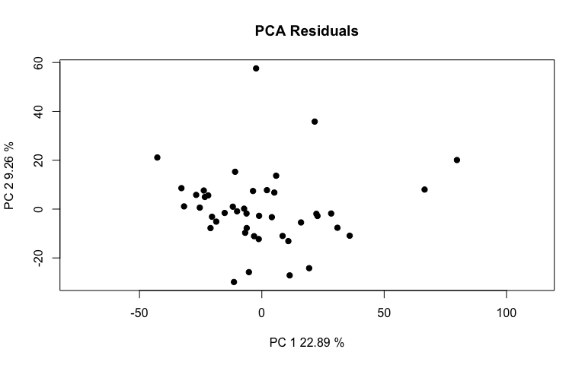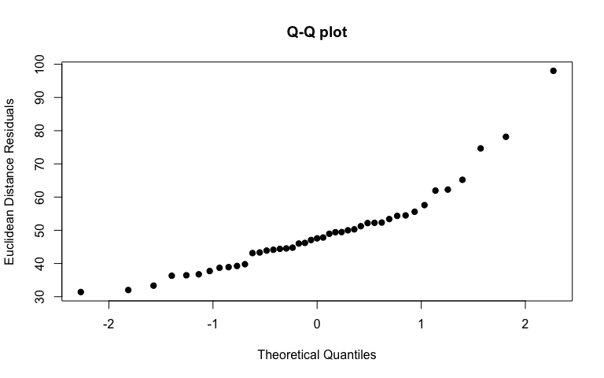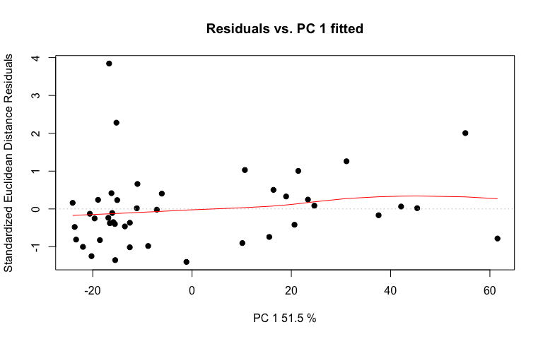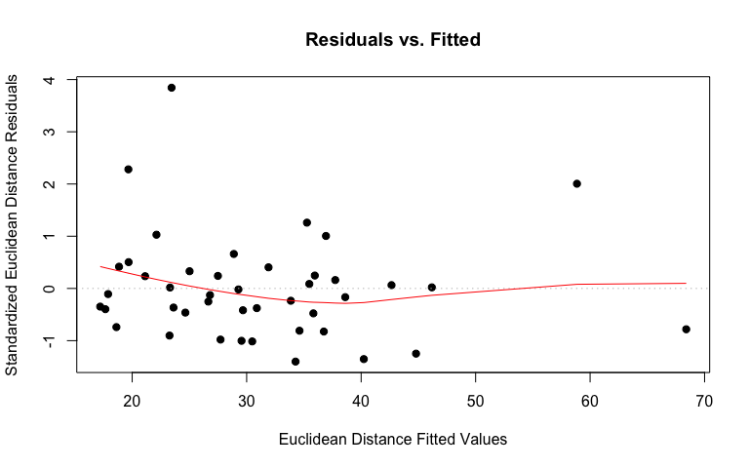

# linear regression plot  
Oregression <- plot(O_LMneg, type = "regression", predictor = class$Fungus,   
 reg.type = "RegScore")

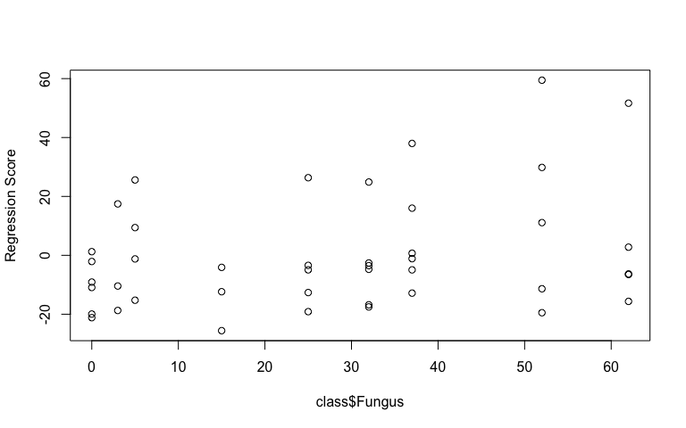

# pca plot  
Opcplot <- plot(O_LMneg, type = "PC", pch = 19, col = interaction(class$Water,   
 class$Fungus))

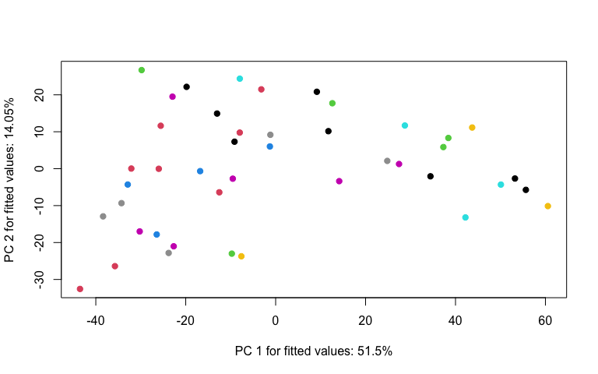

## Young Leaves residuals vs fitted values (homoscedasticity  
## check)  
Ydiagnostics <- plot(Y_LMneg, type = "diagnostics")

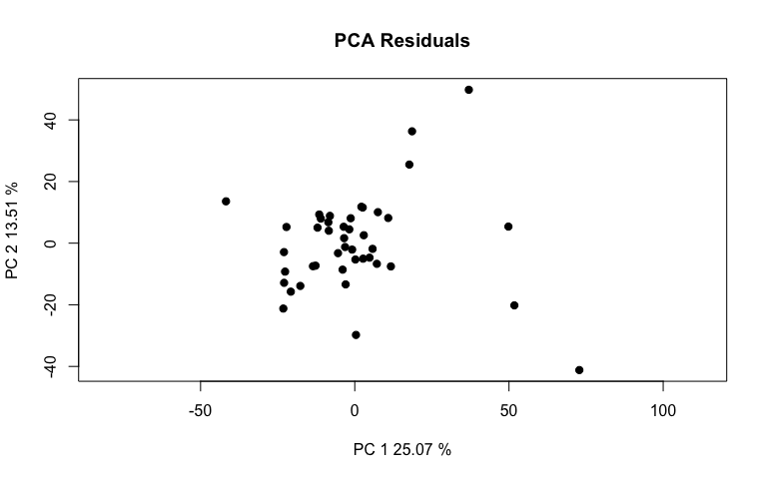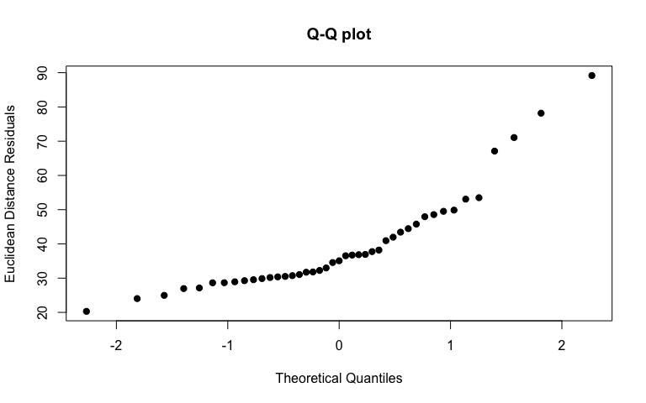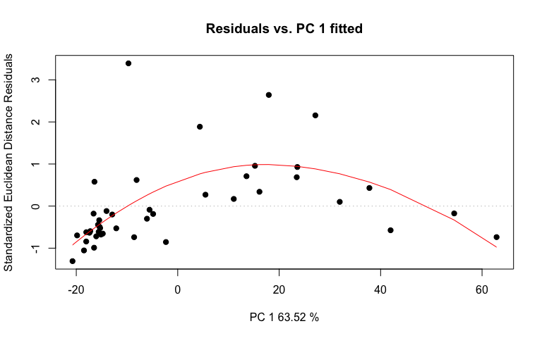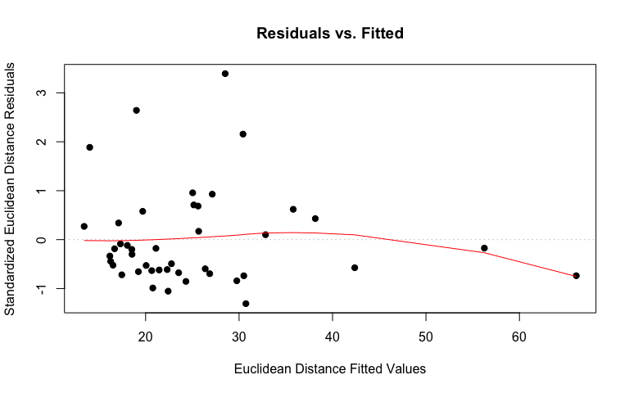

# linear regression plot  
Yregression <- plot(Y_LMneg, type = "regression", predictor = class$Fungus,   
 reg.type = "RegScore")

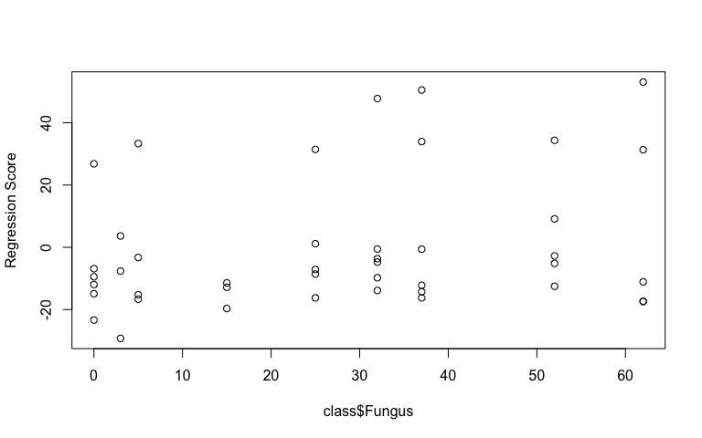

# pca plot  
Ypcplot <- plot(Y_LMneg, type = "PC", pch = 19, col = interaction(class$Water,   
 class$Fungus))

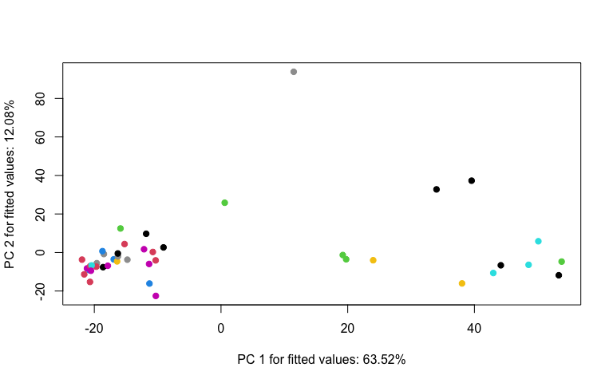

1. Perform an RRPP ANOVA and print results.

## Old Leaves  
OnegANOVA <- anova(O_LMneg, effect.type = "F", error = c("Residuals",   
 "Block:Water", "Block:Water:Fungus", "Residuals", "Block:Water:Fungus",   
 "Block:Water:Fungus", "Residuals"))  
summary(OnegANOVA, formula = T)

##   
## Analysis of Variance, using Residual Randomization  
## Permutation procedure: Randomization of null model residuals   
## Number of permutations: 1000   
## Estimation method: Ordinary Least Squares   
## Sums of Squares and Cross-products: Type III   
## Effect sizes (Z) based on F distributions  
##   
## Df SS MS Rsq F Z Pr(>F)   
## Block 1 3202 3201.5 0.02041 1.0112 0.20301 0.370   
## Water 1 5610 5610.4 0.03577 1.5380 2.09648 0.022 *  
## Fungus 1 5175 5174.6 0.03300 1.4954 1.20511 0.113   
## Block:Water 1 3648 3647.8 0.02326 1.1521 0.56563 0.263   
## Block:Fungus 1 3692 3691.6 0.02354 1.0669 0.29363 0.407   
## Water:Fungus 1 3935 3935.5 0.02509 1.1373 0.71081 0.238   
## Block:Water:Fungus 1 3460 3460.3 0.02206 1.0929 0.35576 0.320   
## Residuals 35 110818 3166.2 0.70662   
## Total 42 156828   
## ---  
## Signif. codes: 0 '***' 0.001 '**' 0.01 '*' 0.05 '.' 0.1 ' ' 1  
##   
## Call: lm.rrpp(f1 = scaled_Y_old ~ Block * Water * Fungus, SS.type = "III",   
## data = class, print.progress = F)

## Young Leaves  
YnegANOVA <- anova(Y_LMneg, effect.type = "F", error = c("Residuals",   
 "Block:Water", "Block:Water:Fungus", "Residuals", "Block:Water:Fungus",   
 "Block:Water:Fungus", "Residuals"))  
summary(YnegANOVA, formula = T)

##   
## Analysis of Variance, using Residual Randomization  
## Permutation procedure: Randomization of null model residuals   
## Number of permutations: 1000   
## Estimation method: Ordinary Least Squares   
## Sums of Squares and Cross-products: Type III   
## Effect sizes (Z) based on F distributions  
##   
## Df SS MS Rsq F Z Pr(>F)   
## Block 1 1885 1885.0 0.01750 0.8680 -0.11886 0.517   
## Water 1 2056 2056.1 0.01909 1.5851 1.86954 0.030 *  
## Fungus 1 4496 4496.5 0.04175 1.8526 1.55113 0.057 .  
## Block:Water 1 1297 1297.1 0.01205 0.5973 -1.17211 0.889   
## Block:Fungus 1 2939 2939.1 0.02729 1.2109 0.56704 0.277   
## Water:Fungus 1 2993 2992.7 0.02779 1.2330 0.83351 0.206   
## Block:Water:Fungus 1 2427 2427.1 0.02254 1.1177 0.43148 0.318   
## Residuals 35 76007 2171.6 0.70580   
## Total 42 107688   
## ---  
## Signif. codes: 0 '***' 0.001 '**' 0.01 '*' 0.05 '.' 0.1 ' ' 1  
##   
## Call: lm.rrpp(f1 = scaled_Y_young ~ Block * Water * Fungus, SS.type = "III",   
## data = class, print.progress = F)

1. Test lm.rrpp model coefficients. “d” is the amount of change in a variable for the coefficient indicated.

## Old Leaves test model coefficients  
Onegcoef <- coef(O_LMneg, test = T)  
summary(Onegcoef)

##   
## Linear Model fit with lm.rrpp  
##   
## Number of observations: 43  
## Number of dependent variables: 3734  
## Data space dimensions: 42  
## Sums of Squares and Cross-products: Type III  
## Number of permutations: 1000  
##   
## Statistics (distances) of coefficients with 95 percent confidence intervals,  
## effect sizes, and probabilities of exceeding observed values based on  
## 1000 random permutations using RRPP   
##   
## d.obs UCL (95%) Zd Pr(>d)  
## (Intercept) 60.3518088 95.1576780 -1.6147590 0.979  
## Block 26.9816761 32.6377501 0.5810541 0.215  
## WaterLow 92.4671749 83.0478713 2.7401007 0.012  
## Fungus 1.8892146 1.8291740 2.1574420 0.036  
## Block:WaterLow 38.4181644 43.0241417 1.0338704 0.137  
## Block:Fungus 0.8183189 0.9240055 0.9726995 0.151  
## WaterLow:Fungus 2.2856809 2.4625126 1.2781698 0.108  
## Block:WaterLow:Fungus 1.0601248 1.2260900 0.7919779 0.192

## Young Leaves test model coefficients  
Ynegcoef <- coef(Y_LMneg, test = T)  
summary(Ynegcoef)

##   
## Linear Model fit with lm.rrpp  
##   
## Number of observations: 43  
## Number of dependent variables: 2564  
## Data space dimensions: 42  
## Sums of Squares and Cross-products: Type III  
## Number of permutations: 1000  
##   
## Statistics (distances) of coefficients with 95 percent confidence intervals,  
## effect sizes, and probabilities of exceeding observed values based on  
## 1000 random permutations using RRPP   
##   
## d.obs UCL (95%) Zd Pr(>d)  
## (Intercept) 44.4893714 77.035800 -1.6998557 0.983  
## Block 20.7034191 28.851289 0.1383966 0.364  
## WaterLow 55.9771863 70.500843 0.3669193 0.299  
## Fungus 1.7610770 1.600200 2.6444701 0.018  
## Block:WaterLow 22.9093040 36.583231 -0.7695439 0.776  
## Block:Fungus 0.7301684 0.819176 1.2218881 0.117  
## WaterLow:Fungus 1.9932055 2.146520 1.4119705 0.084  
## Block:WaterLow:Fungus 0.8878702 1.063849 0.7867375 0.187

WaterLow has the largest effect on the model. The standard is the mean for High water treatment.

1. Compute predicted values from the lm.rrpp model fit using bootstrapped residuals to generate confidence intervals (precision of group mean estimates).

O_pred <- predict(O_LMneg)  
plot(O_pred, PC = T, ellipse = T)

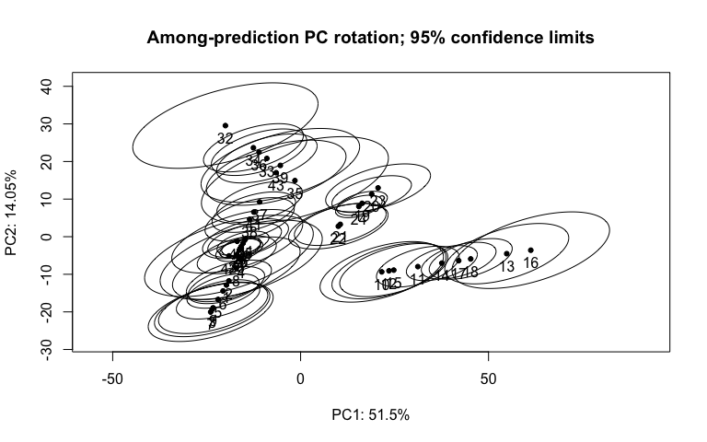

Y_pred <- predict(Y_LMneg)  
plot(Y_pred, PC = T, ellipse = T)

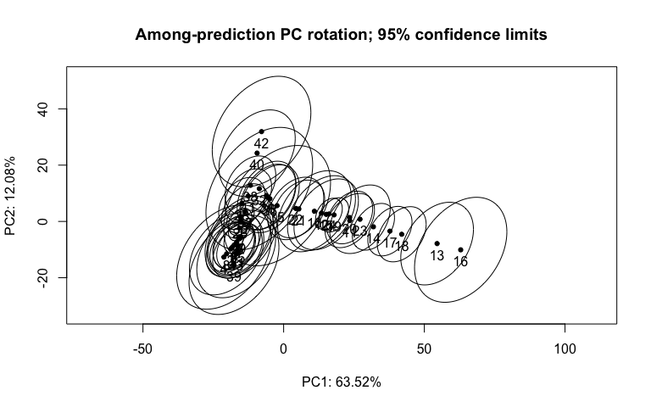

1. Test pairwise differences between least squares means. Similar to tukeyHSD function in the r stats package. The pairwise function will generate tables with confidence intervals and p‐values for the pairwise statistic, Euclidean distance between least‐squares means.

## Old Leaves pairwise differences of water  
Onegpw <- pairwise(O_LMneg, groups = class$Water)  
summary(Onegpw, confidence = 0.95, stat.table = T)

##   
## Pairwise comparisons  
##   
## Groups: High Low   
##   
## RRPP: 1000 permutations  
##   
## LS means:  
## Vectors hidden (use show.vectors = TRUE to view)  
##   
## Pairwise distances between means, plus statistics  
## d UCL (95%) Z Pr > d  
## High:Low 38.34694 49.87041 -0.5777425 0.693

## Young Leaves pairwise differences of water  
Ynegpw <- pairwise(Y_LMneg, groups = class$Water)  
summary(Ynegpw, confidence = 0.95, stat.table = T)

##   
## Pairwise comparisons  
##   
## Groups: High Low   
##   
## RRPP: 1000 permutations  
##   
## LS means:  
## Vectors hidden (use show.vectors = TRUE to view)  
##   
## Pairwise distances between means, plus statistics  
## d UCL (95%) Z Pr > d  
## High:Low 34.62897 44.12792 -0.5132088 0.689

Ynegpw2 <- pairwise(Y_LMneg, groups = class$Fungus)  
summary(Ynegpw2, confidence = 0.95, stat.table = T)

##   
## Pairwise comparisons  
##   
## Groups: 0 3 5 15 25 32 37 52 62   
##   
## RRPP: 1000 permutations  
##   
## LS means:  
## Vectors hidden (use show.vectors = TRUE to view)  
##   
## Pairwise distances between means, plus statistics  
## d UCL (95%) Z Pr > d  
## 0:3 11.967287 18.355618 -1.5437998 0.960  
## 0:5 7.073755 13.489150 -1.6170467 0.992  
## 0:15 8.463239 15.962885 -2.6648850 1.000  
## 0:25 7.249913 15.317896 -1.9298912 0.999  
## 0:32 10.797658 20.945008 -1.4658976 0.972  
## 0:37 12.484792 24.217666 -1.4658976 0.972  
## 0:52 19.500474 34.669590 -1.2158107 0.922  
## 0:62 23.410947 43.584857 -1.3451742 0.937  
## 3:5 14.149716 20.201283 -0.8557056 0.797  
## 3:15 8.923562 14.450566 -1.4093037 0.950  
## 3:25 12.647085 19.839114 -1.9958906 0.989  
## 3:32 12.397093 20.875031 -2.1728750 0.997  
## 3:37 13.281103 22.899146 -2.1188893 0.996  
## 3:52 18.290922 31.825494 -1.6669728 0.987  
## 3:62 20.897656 38.825164 -1.6497027 0.990  
## 5:15 7.559166 11.178094 -0.9053605 0.821  
## 5:25 10.045844 15.942290 -0.7283301 0.744  
## 5:32 13.913808 21.451907 -0.5312014 0.661  
## 5:37 15.397669 24.184723 -0.6010529 0.681  
## 5:52 22.064981 33.955665 -0.4852377 0.637  
## 5:62 25.678135 41.355658 -0.7593210 0.765  
## 15:25 7.934798 12.773747 -1.7897362 0.989  
## 15:32 9.834148 16.490910 -1.1818510 0.917  
## 15:37 11.031471 18.671089 -1.1332872 0.902  
## 15:52 16.772019 26.892873 -0.7745148 0.761  
## 15:62 20.435333 35.006860 -1.0294169 0.855  
## 25:32 4.796356 6.969520 -0.6801663 0.744  
## 25:37 6.280954 9.987427 -0.8752117 0.803  
## 25:52 13.445915 20.416946 -0.6367510 0.711  
## 25:62 17.520881 29.313591 -1.0832902 0.868  
## 32:37 1.687134 3.272658 -1.4658976 0.972  
## 32:52 9.437433 14.848263 -0.8593867 0.813  
## 32:62 12.949955 22.882762 -1.2418133 0.916  
## 37:52 8.039163 12.128741 -0.7536081 0.764  
## 37:62 11.372417 19.770866 -1.2092249 0.908  
## 52:62 7.696395 15.320555 -1.5126342 0.979

## PCA

1. Identify the major source of variation in data and determine if the variation is sourced from experimental bias or biological conditions.

# Old Leaf Secondary Metabolites (Neg) tune how many  
# components to use  
tune.pca(scaled_Y_old)

## Eigenvalues for the first 10 principal components, see object$sdev^2:   
## PC1 PC2 PC3 PC4 PC5 PC6 PC7   
## 1006.12346 296.26837 272.74967 229.43449 201.77791 159.01902 137.05643   
## PC8 PC9 PC10   
## 117.36477 99.56505 83.39669   
##   
## Proportion of explained variance for the first 10 principal components, see object$explained_variance:   
## PC1 PC2 PC3 PC4 PC5 PC6 PC7   
## 0.26944924 0.07934343 0.07304490 0.06144470 0.05403801 0.04258678 0.03670499   
## PC8 PC9 PC10   
## 0.03143138 0.02666445 0.02233441   
##   
## Cumulative proportion explained variance for the first 10 principal components, see object$cum.var:   
## PC1 PC2 PC3 PC4 PC5 PC6 PC7 PC8   
## 0.2694492 0.3487927 0.4218376 0.4832823 0.5373203 0.5799070 0.6166120 0.6480434   
## PC9 PC10   
## 0.6747079 0.6970423   
##   
## Other available components:   
## --------------------   
## loading vectors: see object$rotation

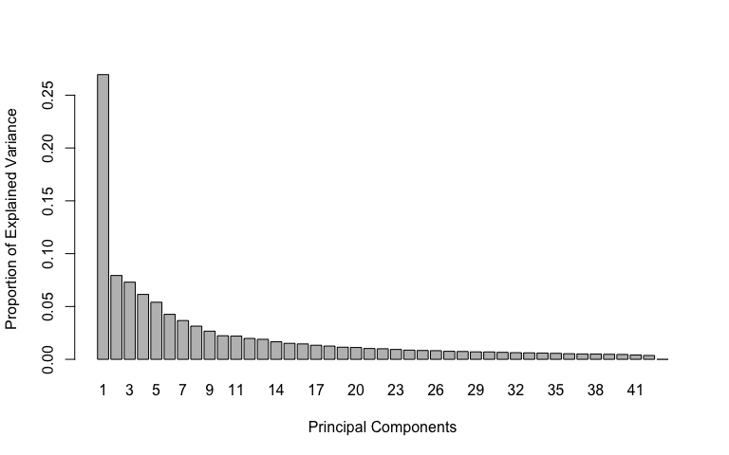

pca.res <- mixOmics::pca(scaled_Y_old, ncomp = 4, scale = F)  
  
# plot pca  
plotIndiv(pca.res, group = class$Water, ind.names = F, pch = as.factor(class$Fungus),   
 legend = T, legend.title = "Water", legend.title.pch = "Fungus",   
 title = "Old Leaf Secondary Metabolites (Neg) PCA")

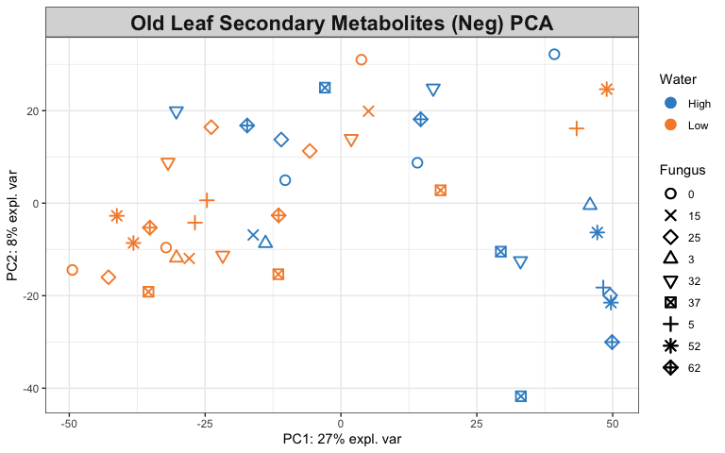

# Look at variable coefficients in each component with the  
# loading vectors The absolute value of loading vectors  
# represent the importance of each variable to define each PC  
plotLoadings(pca.res, ndisplay = 50)

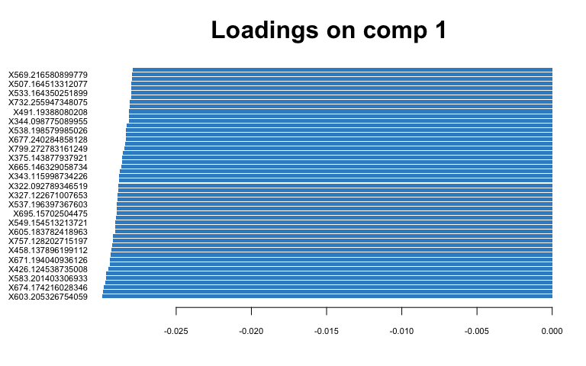

# Young Leaf Secondary Metabolites (Neg) tune how many  
# components to use  
tune.pca(scaled_Y_young)

## Eigenvalues for the first 10 principal components, see object$sdev^2:   
## PC1 PC2 PC3 PC4 PC5 PC6 PC7 PC8   
## 741.29628 412.41616 243.17081 131.73675 117.94156 99.99428 90.34507 80.27160   
## PC9 PC10   
## 46.91985 45.51224   
##   
## Proportion of explained variance for the first 10 principal components, see object$explained_variance:   
## PC1 PC2 PC3 PC4 PC5 PC6 PC7   
## 0.28911711 0.16084874 0.09484041 0.05137939 0.04599905 0.03899933 0.03523599   
## PC8 PC9 PC10   
## 0.03130718 0.01829947 0.01775048   
##   
## Cumulative proportion explained variance for the first 10 principal components, see object$cum.var:   
## PC1 PC2 PC3 PC4 PC5 PC6 PC7 PC8   
## 0.2891171 0.4499658 0.5448063 0.5961856 0.6421847 0.6811840 0.7164200 0.7477272   
## PC9 PC10   
## 0.7660267 0.7837771   
##   
## Other available components:   
## --------------------   
## loading vectors: see object$rotation

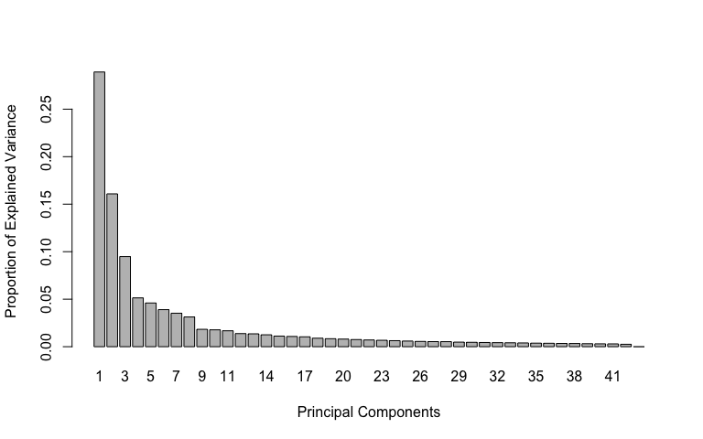

pca.res <- mixOmics::pca(scaled_Y_young, ncomp = 3, scale = F)  
  
# plot pca  
plotIndiv(pca.res, group = class$Water, ind.names = F, pch = as.factor(class$Fungus),   
 legend = T, legend.title = "Water", legend.title.pch = "Fungus",   
 title = "Young Leaf Secondary Metabolites (Neg) PCA")

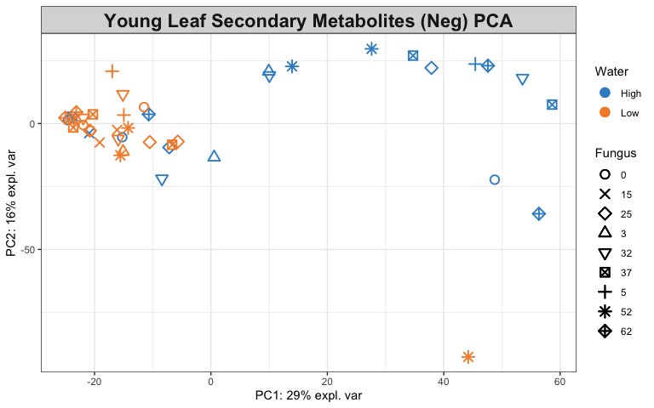

# Look at variable coefficients in each component with the  
# loading vectors The absolute value of loading vectors  
# represent the importance of each variable to define each PC  
plotLoadings(pca.res, ndisplay = 50)

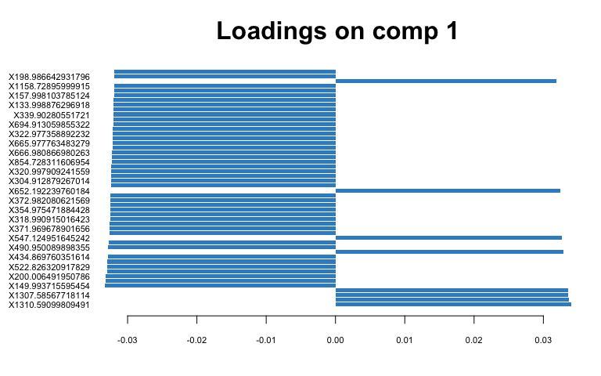

1. Identify the variables that contribute to the explained variance.

# Old Leaf  
spca.res <- mixOmics::spca(scaled_Y_old, ncomp = 4, keepX = c(100,   
 100, 10, 10))  
  
# plot spca  
plotIndiv(spca.res, group = class$Water, ind.names = F, pch = as.factor(class$Fungus),   
 legend = T, legend.title = "Water", legend.title.pch = "Fungus",   
 title = "Old Leaf Secondary Metabolites (Neg) sPCA")

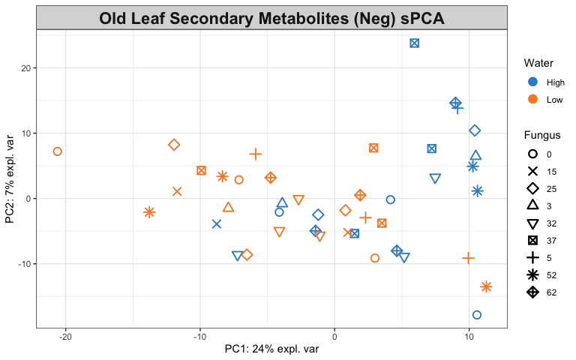

# variables contributing to each component  
plotVar(spca.res, cex = 1)

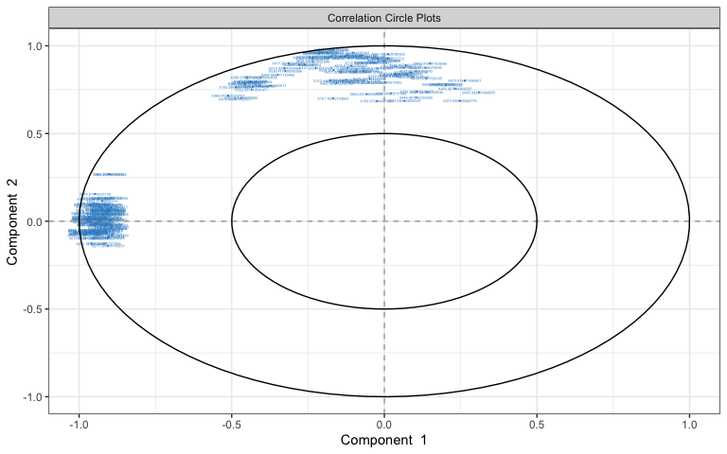

selectVar(spca.res, comp = 1)$value # view loading value of each metabolite

## value.var  
## X539.200396017582 -0.181082951  
## X537.196397367603 -0.177118557  
## X689.139568989934 -0.176379501  
## X605.183782418963 -0.174908432  
## X538.199827871219 -0.174730140  
## X606.187523014034 -0.173086641  
## X673.171512158096 -0.170842206  
## X674.174216028346 -0.170227465  
## X757.128202715197 -0.164840111  
## X673.170424561307 -0.162356814  
## X566.195673145549 -0.158134925  
## X606.186978663872 -0.155743982  
## X538.199494433559 -0.154379050  
## X508.189553957924 -0.152111850  
## X605.183549351429 -0.150829867  
## X537.196150052541 -0.148851518  
## X507.186328234882 -0.148529026  
## X605.183770693646 -0.146771927  
## X674.174026648318 -0.144312231  
## X569.215412674731 -0.141371483  
## X345.134077182166 -0.140059056  
## X565.192217935211 -0.139170771  
## X621.154757691745 -0.138209140  
## X535.180816690394 -0.137719228  
## X375.143877937921 -0.136720111  
## X695.15702504475 -0.132672803  
## X536.183781917591 -0.127150509  
## X667.156131811396 -0.126185948  
## X603.170193450933 -0.123359380  
## X604.173915958927 -0.123282579  
## X896.338024188277 -0.122276357  
## X586.219348942499 -0.120032704  
## X506.173570612014 -0.119838045  
## X537.195007794578 -0.117466739  
## X719.284172253939 -0.116608140  
## X665.146329058734 -0.115605747  
## X606.186970859362 -0.115319414  
## X603.205326754059 -0.114899908  
## X668.159851943747 -0.111049129  
## X585.21616223106 -0.110936526  
## X895.335059889362 -0.106853883  
## X343.115998734226 -0.101118943  
## X505.170366397634 -0.100061246  
## X567.207353749129 -0.097753184  
## X538.198579985026 -0.097218515  
## X327.122671007653 -0.095158658  
## X568.210597694665 -0.094806479  
## X604.208532818709 -0.094428877  
## X583.201403306933 -0.090439718  
## X610.182262413814 -0.076973370  
## X346.140373954959 -0.069376435  
## X570.219543443364 -0.067921138  
## X149.059073075148 -0.065194016  
## X893.31996552376 -0.065091823  
## X833.181144939018 -0.062452460  
## X727.178420224907 -0.058258959  
## X671.194040936126 -0.054279193  
## X720.286487727369 -0.053767576  
## X457.134224463719 -0.052892192  
## X878.329634092335 -0.049771260  
## X731.252742703494 -0.048911141  
## X735.146845005385 -0.048670427  
## X540.215185799472 -0.047788147  
## X803.137206404634 -0.046133144  
## X613.210520581568 -0.045375543  
## X653.178879325056 -0.042429292  
## X507.164513312077 -0.042115852  
## X508.174573318256 -0.042074589  
## X817.214095360852 -0.040853774  
## X458.137896199112 -0.040246045  
## X481.170644965179 -0.039170292  
## X877.32639228893 -0.037250992  
## X677.166894727587 -0.036928503  
## X716.259282733113 -0.032230304  
## X549.154513213721 -0.031683394  
## X879.340062720795 -0.030671329  
## X376.132023520547 -0.030608230  
## X894.32300346217 -0.030321790  
## X527.175065407586 -0.028133102  
## X732.255947348075 -0.027703876  
## X271.096810106801 -0.027347261  
## X528.177807869861 -0.027319604  
## X521.201790047362 -0.026797953  
## X589.18940461419 -0.025996732  
## X516.148124468326 -0.025001523  
## X584.20513749326 -0.023886833  
## X717.21276012974 -0.023767090  
## X698.250989243722 -0.018573314  
## X515.14524575838 -0.016156106  
## X583.201760969925 -0.015767460  
## X880.34365929126 -0.014726899  
## X796.233580680884 -0.012552486  
## X439.157924608228 -0.010533966  
## X489.162112886893 -0.010227638  
## X359.148741949471 -0.009070205  
## X426.124538735008 -0.007881174  
## X795.230947111927 -0.007269924  
## X799.272783161249 -0.003948915  
## X330.141938124165 -0.003220751  
## X993.322387841374 -0.002683019

# plot loadings for comp 1  
plotLoadings(spca.res, ndisplay = 50)

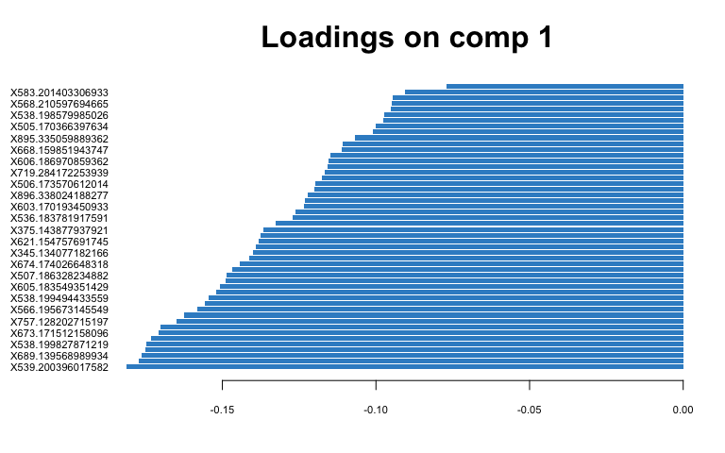

# plot loadings for comp 2  
plotLoadings(spca.res, comp = 2, ndisplay = 50)

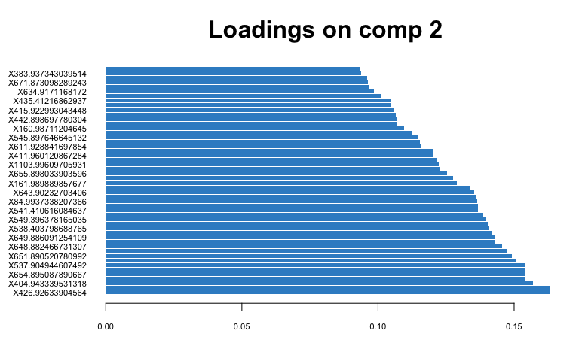

# Young Leaf  
spca.res <- mixOmics::spca(scaled_Y_young, ncomp = 3, keepX = c(100,   
 100, 10))  
  
# plot spca  
plotIndiv(spca.res, group = class$Water, ind.names = F, pch = as.factor(class$Fungus),   
 legend = T, legend.title = "Water", legend.title.pch = "Fungus",   
 title = "Young Leaf Secondary Metabolites (Neg) sPCA")

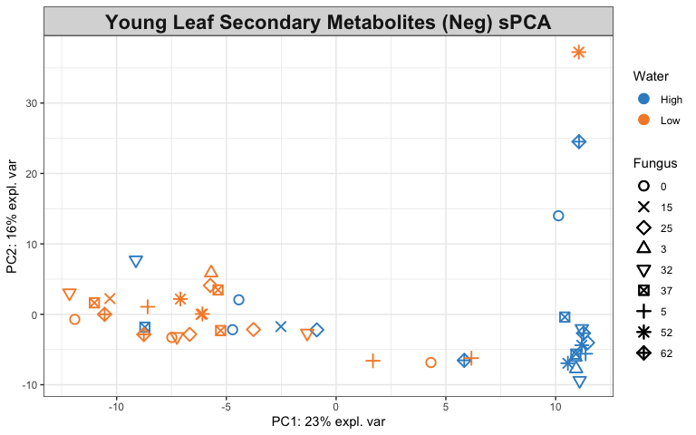

# variables contributing to each component  
plotVar(spca.res, cex = 1)

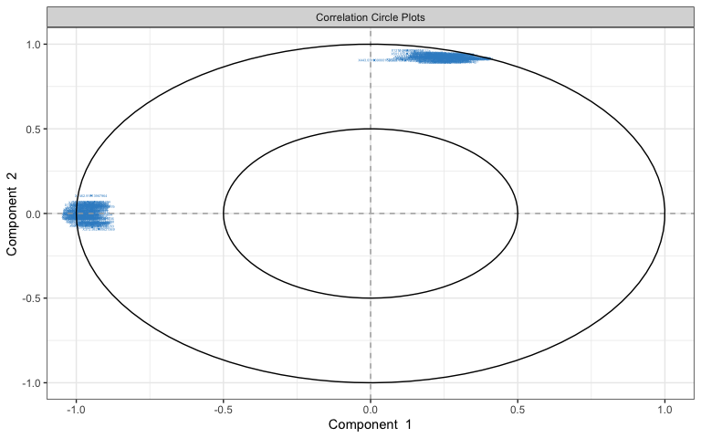

selectVar(spca.res, comp = 1)$value # view loading value of each metabolite

## value.var  
## X845.998051933969 -0.1606330732  
## X657.982854820673 -0.1588913910  
## X671.998240343484 -0.1570044653  
## X1018.98243765579 -0.1558509302  
## X656.967401543664 -0.1542198021  
## X847.009461460586 -0.1513489387  
## X482.966873192152 -0.1507840595  
## X768.942262814837 -0.1507794924  
## X1192.98175033474 -0.1505850124  
## X942.945320263561 -0.1498940009  
## X1003.95747365641 -0.1483768457  
## X1019.99560196699 -0.1475759336  
## X674.016483703087 -0.1468869753  
## X1115.92973111084 -0.1452322948  
## X769.960119302684 -0.1452289240  
## X941.927736931021 -0.1451711041  
## X1004.9693465925 -0.1429543394  
## X844.982584773594 -0.1425938797  
## X1191.96821780793 -0.1414755075  
## X1193.99113116688 -0.1367830091  
## X673.010580970203 -0.1350161100  
## X546.988591117921 -0.1333992604  
## X309.981088265932 -0.1311783631  
## X1365.96770825737 -0.1308576944  
## X1036.98344363687 -0.1291475627  
## X497.995790827568 -0.1284198692  
## X595.956622450094 -0.1276729024  
## X421.955540488549 -0.1247260506  
## X720.988827959216 -0.1233755750  
## X654.985813378408 -0.1208239906  
## X326.018113960963 -0.1202548234  
## X893.974082323864 -0.1185839446  
## X499.011279134568 -0.1180404580  
## X831.984075771083 -0.1152274812  
## X767.92526913147 -0.1144326983  
## X827.971822574841 -0.1130674947  
## X325.016405270187 -0.1120384107  
## X658.999544129286 -0.1111185579  
## X1017.96708598534 -0.1110301332  
## X632.970118158626 -0.1101401694  
## X1366.97865046669 -0.1073823625  
## X1116.94487167345 -0.1039494146  
## X670.981382467921 -0.1035217899  
## X500.018284225597 -0.1032308499  
## X374.002078378787 -0.1015634926  
## X1021.00089889269 -0.0993725768  
## X323.995293823304 -0.0987291486  
## X283.006624782518 -0.0979302194  
## X1289.93083614531 -0.0944013782  
## X322.011417255538 -0.0940995915  
## X1002.95537959577 -0.0924342460  
## X943.961229494259 -0.0915650916  
## X320.997909241559 -0.0907305440  
## X849.977486523324 -0.0900179868  
## X548.002503827387 -0.0864849042  
## X1364.95342014471 -0.0848014939  
## X667.985410425584 -0.0825819686  
## X1539.96588681403 -0.0818807443  
## X439.973315198955 -0.0747832594  
## X1177.95950779409 -0.0705672962  
## X1537.94035488602 -0.0702813560  
## X1176.95174154844 -0.0693124850  
## X311.000291548275 -0.0673917656  
## X1190.95179773088 -0.0660990078  
## X297.965942084671 -0.0659084293  
## X151.01222317911 -0.0641287500  
## X828.975599111753 -0.0627652369  
## X1462.91813967964 -0.0582347094  
## X492.989329994173 -0.0568171097  
## X655.964796055963 -0.0556936893  
## X1209.9715082933 -0.0554816541  
## X1001.96773728958 -0.0511680114  
## X496.976355787476 -0.0504382102  
## X843.965940610961 -0.0496897756  
## X200.006491950786 -0.0493434127  
## X485.000453042681 -0.0492835816  
## X1005.98287863099 -0.0484741503  
## X894.987582775265 -0.0484167703  
## X1288.91771445373 -0.0466471937  
## X892.958412895177 -0.0465485025  
## X840.974050128923 -0.0462979834  
## X675.97602596745 -0.0462678146  
## X493.984197587741 -0.0442490380  
## X832.995567847355 -0.0441367913  
## X1066.96015657453 -0.0439418244  
## X483.981165431415 -0.0373671386  
## X862.985775931247 -0.0364052212  
## X653.970909319968 -0.0362206773  
## X839.970909295556 -0.0334228170  
## X1067.97416491294 -0.0331244928  
## X494.99544329672 -0.0317928369  
## X1538.95350383304 -0.0308769093  
## X1114.9157769402 -0.0284955747  
## X1016.95098645776 -0.0219369799  
## X506.971749443834 -0.0166512968  
## X676.816971205036 -0.0063743103  
## X666.980866980263 -0.0054246355  
## X308.001278383708 -0.0041169721  
## X1187.95480089979 -0.0008532640  
## X372.982080621569 -0.0001506316

# plot loadings for comp 1  
plotLoadings(spca.res, ndisplay = 50)

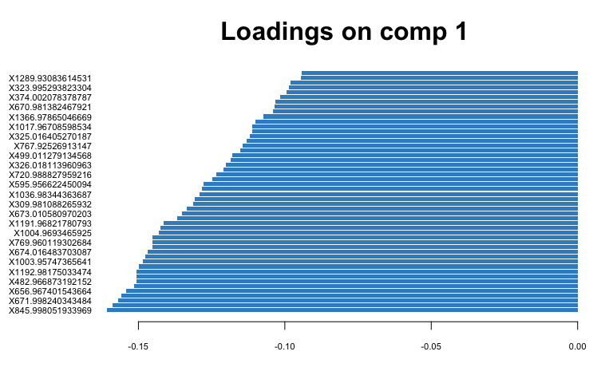

# plot loadings for comp 2  
plotLoadings(spca.res, comp = 2, ndisplay = 50)

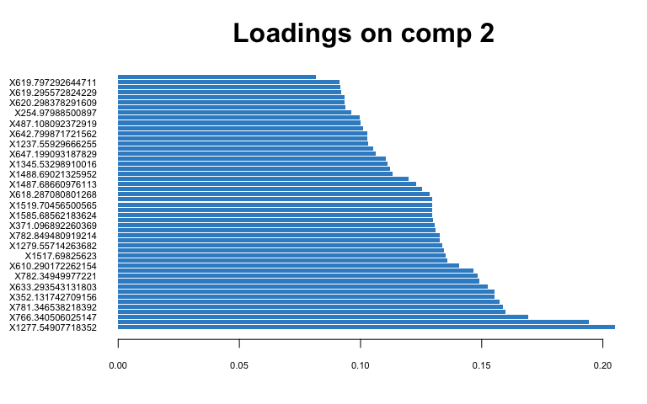

## PLS-DA

1. Classify samples into known groups and predict the class of new samples.

# Old Leaf  
old.splsda <- mixOmics::splsda(scaled_Y_old, class$Water, keepX = c(100,   
 100))  
  
# plot pls-da  
plotIndiv(old.splsda, ind.names = F, legend = T, title = "Old Leaf Secondary Metabolites (Neg) PLS-DA",   
 legend.title = "Water", ellipse = T)

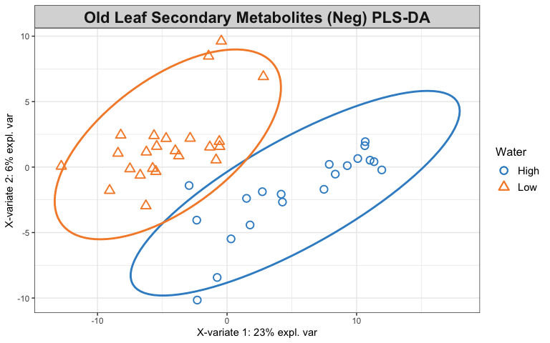

# plot and select the variables  
plotVar(old.splsda)

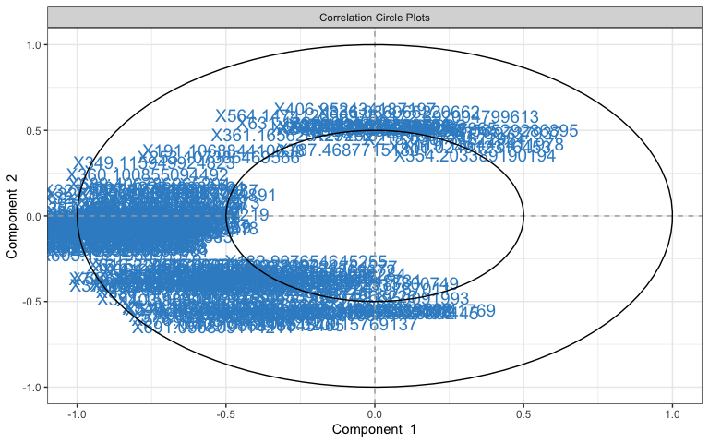

selectVar(old.splsda, comp = 1)

## $name  
## [1] "X360.100855094492" "X689.406786965204" "X313.092613575399"  
## [4] "X325.111894653303" "X185.190588615838" "X324.137371517562"  
## [7] "X323.133879784681" "X690.410098388308" "X389.160740120785"  
## [10] "X691.422542368164" "X319.157448204942" "X367.123501601156"  
## [13] "X321.173284297382" "X555.093874891555" "X391.122971286377"  
## [16] "X944.449967310942" "X317.074072751279" "X322.17642106672"   
## [19] "X1240.15789775369" "X639.046287279312" "X183.175015349613"  
## [22] "X351.128821579971" "X169.989509429336" "X556.097536191383"  
## [25] "X420.119920756105" "X1242.17308762521" "X365.145723604088"  
## [28] "X232.95540138555" "X373.115564667084" "X503.071140727181"  
## [31] "X564.931775721697" "X623.08265073133" "X943.448842600956"  
## [34] "X419.116546770163" "X571.058061473006" "X1058.40882060084"  
## [37] "X671.194040936126" "X344.098775089955" "X352.132376994544"  
## [40] "X483.86951634573" "X351.129035832649" "X324.173145983115"  
## [43] "X459.11029979044" "X1178.17585807417" "X487.104967151007"  
## [46] "X578.160197428851" "X320.160371151912" "X359.097883259062"  
## [49] "X349.115949924823" "X431.154386005126" "X604.208532818709"  
## [52] "X340.075145186925" "X779.244559972528" "X537.082677183086"  
## [55] "X481.088866272944" "X435.08241905927" "X1243.17676615566"  
## [58] "X707.029978476026" "X488.109293490248" "X461.06951805573"   
## [61] "X380.158184370181" "X561.03604963324" "X737.232626061852"  
## [64] "X403.160178776661" "X648.205609857975" "X402.11215295727"   
## [67] "X483.119144506346" "X341.965577057768" "X531.066415927912"  
## [70] "X727.164615818962" "X379.328828228171" "X253.107386469566"  
## [73] "X582.225274749511" "X538.198579985026" "X509.112370096629"  
## [76] "X797.114458482459" "X170.985886728112" "X339.118846056087"  
## [79] "X605.192195695578" "X581.222187754695" "X317.075176414668"  
## [82] "X480.872661584228" "X191.106884410638" "X337.077569276891"  
## [85] "X813.080943994947" "X274.831245724891" "X1244.17196607701"  
## [88] "X125.083041728111" "X403.124191936883" "X745.249207080709"  
## [91] "X492.892293308974" "X173.831930748219" "X420.157767082518"  
## [94] "X1411.56721539583" "X173.117683745721" "X326.186522086171"  
## [97] "X177.054713421273" "X363.089853013778" "X338.08099104949"   
## [100] "X379.056256037961"  
##   
## $value  
## value.var  
## X360.100855094492 -0.343087113  
## X689.406786965204 -0.243980813  
## X313.092613575399 -0.212848057  
## X325.111894653303 -0.210978045  
## X185.190588615838 -0.201115999  
## X324.137371517562 -0.195958410  
## X323.133879784681 -0.179196447  
## X690.410098388308 -0.163741506  
## X389.160740120785 -0.161347090  
## X691.422542368164 -0.153900693  
## X319.157448204942 -0.152947273  
## X367.123501601156 -0.147500421  
## X321.173284297382 -0.144279341  
## X555.093874891555 -0.144164122  
## X391.122971286377 -0.143791645  
## X944.449967310942 -0.143389701  
## X317.074072751279 -0.138157675  
## X322.17642106672 -0.127191868  
## X1240.15789775369 -0.126435373  
## X639.046287279312 -0.124081960  
## X183.175015349613 -0.122999679  
## X351.128821579971 -0.122763557  
## X169.989509429336 -0.120186465  
## X556.097536191383 -0.117034237  
## X420.119920756105 -0.115473266  
## X1242.17308762521 -0.112731694  
## X365.145723604088 -0.111058298  
## X232.95540138555 -0.110330724  
## X373.115564667084 -0.104760137  
## X503.071140727181 -0.104718524  
## X564.931775721697 -0.102057012  
## X623.08265073133 -0.099408492  
## X943.448842600956 -0.097763217  
## X419.116546770163 -0.096815661  
## X571.058061473006 -0.095732735  
## X1058.40882060084 -0.092767379  
## X671.194040936126 -0.090464559  
## X344.098775089955 -0.088669610  
## X352.132376994544 -0.085510281  
## X483.86951634573 -0.082308021  
## X351.129035832649 -0.082287182  
## X324.173145983115 -0.077698371  
## X459.11029979044 -0.077395460  
## X1178.17585807417 -0.076698722  
## X487.104967151007 -0.075986692  
## X578.160197428851 -0.075288966  
## X320.160371151912 -0.074244898  
## X359.097883259062 -0.074035136  
## X349.115949924823 -0.073591353  
## X431.154386005126 -0.072490068  
## X604.208532818709 -0.072236378  
## X340.075145186925 -0.071596818  
## X779.244559972528 -0.071183880  
## X537.082677183086 -0.069883004  
## X481.088866272944 -0.068707232  
## X435.08241905927 -0.068085888  
## X1243.17676615566 -0.056126462  
## X707.029978476026 -0.055657940  
## X488.109293490248 -0.055151086  
## X461.06951805573 -0.053574443  
## X380.158184370181 -0.051874729  
## X561.03604963324 -0.050211614  
## X737.232626061852 -0.049763044  
## X403.160178776661 -0.049653036  
## X648.205609857975 -0.048848009  
## X402.11215295727 -0.045746915  
## X483.119144506346 -0.043102012  
## X341.965577057768 -0.042460376  
## X531.066415927912 -0.040675698  
## X727.164615818962 -0.040650908  
## X379.328828228171 -0.033741877  
## X253.107386469566 -0.033311519  
## X582.225274749511 -0.029564631  
## X538.198579985026 -0.028853103  
## X509.112370096629 -0.028625407  
## X797.114458482459 -0.028095612  
## X170.985886728112 -0.027017507  
## X339.118846056087 -0.026546405  
## X605.192195695578 -0.026545106  
## X581.222187754695 -0.026514681  
## X317.075176414668 -0.025846378  
## X480.872661584228 -0.024447803  
## X191.106884410638 -0.019600042  
## X337.077569276891 -0.017707061  
## X813.080943994947 -0.015917969  
## X274.831245724891 -0.013837994  
## X1244.17196607701 -0.012832722  
## X125.083041728111 -0.011628397  
## X403.124191936883 -0.011363122  
## X745.249207080709 -0.010654157  
## X492.892293308974 -0.008953790  
## X173.831930748219 -0.008696817  
## X420.157767082518 -0.007923736  
## X1411.56721539583 -0.006699450  
## X173.117683745721 -0.005112417  
## X326.186522086171 -0.002636670  
## X177.054713421273 -0.002103826  
## X363.089853013778 -0.002103020  
## X338.08099104949 -0.001091795  
## X379.056256037961 -0.001047459  
##   
## $comp  
## [1] 1

plotLoadings(old.splsda, contrib = "max", method = "mean", ndisplay = 50)

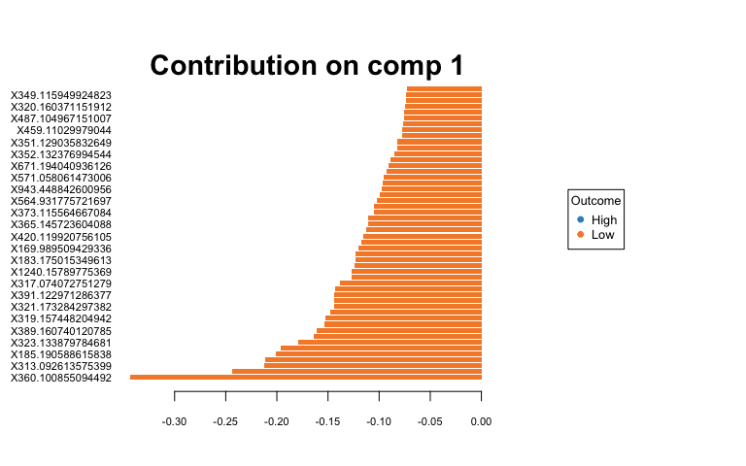

# Young Leaf  
young.splsda <- mixOmics::splsda(scaled_Y_young, class$Water,   
 keepX = c(100, 100))  
young.splsda2 <- mixOmics::splsda(scaled_Y_young, class$Fungus,   
 keepX = c(100, 100))  
  
# plot pls-da  
plotIndiv(young.splsda, ind.names = F, legend = T, title = "Young Leaf Secondary Met. (Neg) PLS-DA",   
 legend.title = "Water", ellipse = T)

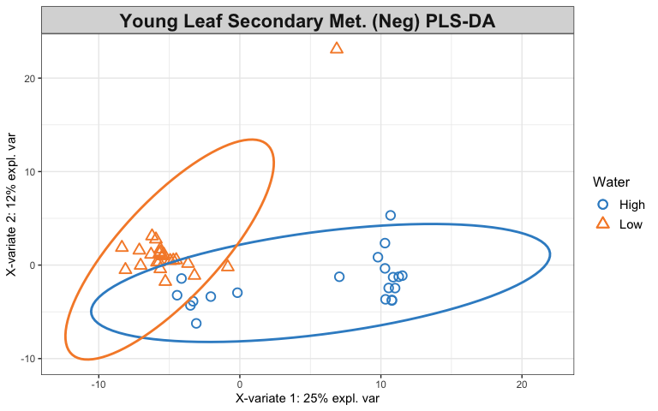

plotIndiv(young.splsda2, ind.names = F, legend = T, title = "Young Leaf Secondary Met. (Neg) PLS-DA",   
 legend.title = "Fungus", ellipse = T)

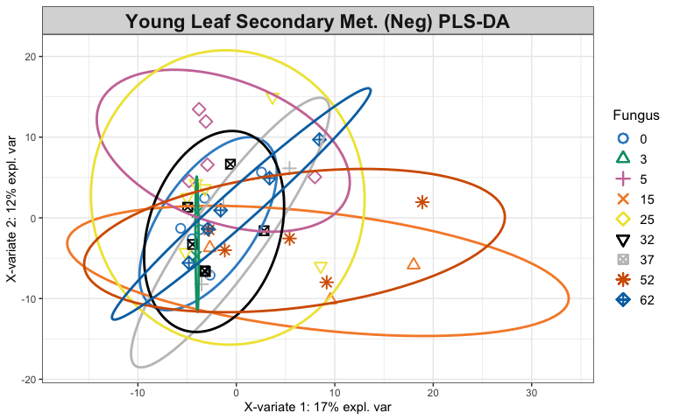

# plot and select the variables  
plotVar(young.splsda)

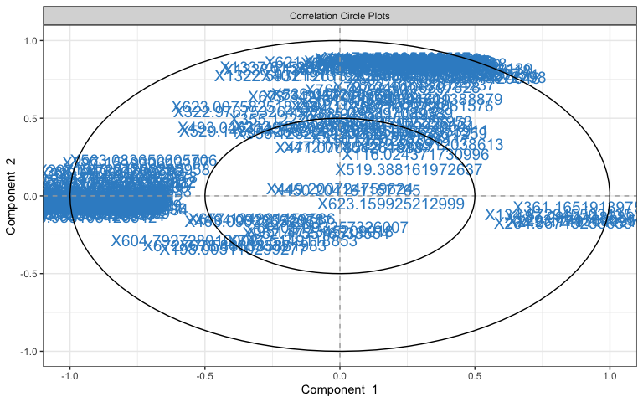

selectVar(young.splsda, comp = 1)

## $name  
## [1] "X150.105130035688" "X802.732174968048" "X242.174914449158"  
## [4] "X1124.61055906716" "X676.816971205036" "X1150.60468753138"  
## [7] "X838.711000805533" "X782.740233674195" "X151.01222317911"   
## [10] "X325.016405270187" "X849.977486523324" "X872.724302253429"  
## [13] "X149.993715595454" "X1192.58529322529" "X1540.97796285958"  
## [16] "X754.740789349138" "X200.006491950786" "X293.174369095004"  
## [19] "X1294.70679432442" "X1348.5287504802" "X1386.51213623856"  
## [22] "X848.720751962966" "X1158.59946171176" "X121.99862199071"   
## [25] "X794.733724869254" "X110.006290772417" "X323.992919982561"  
## [28] "X1090.73888347575" "X1154.60400860062" "X798.726524348207"  
## [31] "X1110.61644505682" "X323.995293823304" "X283.006624782518"  
## [34] "X804.740427603084" "X1066.63653837698" "X1160.5969683167"   
## [37] "X674.818219943495" "X627.923106883369" "X1036.98344363687"  
## [40] "X756.735148419103" "X844.982584773594" "X1116.61329569819"  
## [43] "X326.018113960963" "X1364.95342014471" "X852.733071582736"  
## [46] "X322.976781158022" "X297.307224802892" "X866.707975254094"  
## [49] "X497.995790827568" "X822.723393027696" "X830.737149656595"  
## [52] "X133.998876296918" "X482.966873192152" "X874.707571794695"  
## [55] "X424.843687850262" "X1158.72895999915" "X671.998240343484"  
## [58] "X369.877177619296" "X1350.52689216505" "X1539.96588681403"  
## [61] "X297.151930643187" "X850.821164746369" "X484.12840584078"   
## [64] "X1078.62469612196" "X134.872945563435" "X845.998051933969"  
## [67] "X840.71024774808" "X514.986512120569" "X421.955540488549"  
## [70] "X751.803644269174" "X828.732413615017" "X563.083650605706"  
## [73] "X1019.99560196699" "X1191.96821780793" "X152.014000365393"  
## [76] "X1018.98243765579" "X1138.61401223754" "X892.958412895177"  
## [79] "X1192.98175033474" "X632.970118158626" "X361.165191397563"  
## [82] "X558.938103128542" "X854.728311606954" "X896.710609558084"  
## [85] "X843.965940610961" "X670.981382467921" "X657.982854820673"  
## [88] "X366.142530296776" "X538.815638527027" "X264.967492566591"  
## [91] "X187.096414888931" "X1128.61230614359" "X824.820684339506"  
## [94] "X826.731366769468" "X1177.95950779409" "X337.904579660098"  
## [97] "X1711.93957530353" "X916.69988248716" "X1103.61628997104"  
## [100] "X339.90280551721"   
##   
## $value  
## value.var  
## X150.105130035688 -0.282039719  
## X802.732174968048 -0.227414352  
## X242.174914449158 0.215910257  
## X1124.61055906716 -0.198782419  
## X676.816971205036 -0.192655075  
## X1150.60468753138 -0.183273749  
## X838.711000805533 -0.181332267  
## X782.740233674195 -0.180686657  
## X151.01222317911 -0.176989099  
## X325.016405270187 -0.175849728  
## X849.977486523324 -0.174259645  
## X872.724302253429 -0.160769967  
## X149.993715595454 -0.156421706  
## X1192.58529322529 -0.154190387  
## X1540.97796285958 -0.151174229  
## X754.740789349138 -0.149717546  
## X200.006491950786 -0.149376121  
## X293.174369095004 0.144319007  
## X1294.70679432442 -0.140253834  
## X1348.5287504802 -0.137292240  
## X1386.51213623856 -0.134315079  
## X848.720751962966 -0.131984710  
## X1158.59946171176 -0.128594472  
## X121.99862199071 -0.126133016  
## X794.733724869254 -0.124014822  
## X110.006290772417 -0.122819961  
## X323.992919982561 -0.115547980  
## X1090.73888347575 -0.114224424  
## X1154.60400860062 -0.109269030  
## X798.726524348207 -0.102943924  
## X1110.61644505682 -0.100529543  
## X323.995293823304 -0.100100667  
## X283.006624782518 -0.098992349  
## X804.740427603084 -0.092445129  
## X1066.63653837698 -0.088592213  
## X1160.5969683167 -0.088291119  
## X674.818219943495 -0.085416018  
## X627.923106883369 -0.083266055  
## X1036.98344363687 -0.083040165  
## X756.735148419103 -0.081939466  
## X844.982584773594 -0.081009163  
## X1116.61329569819 -0.077158656  
## X326.018113960963 -0.073578175  
## X1364.95342014471 -0.073276382  
## X852.733071582736 -0.073097286  
## X322.976781158022 -0.071190101  
## X297.307224802892 -0.070158011  
## X866.707975254094 -0.066433552  
## X497.995790827568 -0.066224702  
## X822.723393027696 -0.066184178  
## X830.737149656595 -0.063541450  
## X133.998876296918 -0.063294993  
## X482.966873192152 -0.063122686  
## X874.707571794695 -0.059919434  
## X424.843687850262 -0.059134367  
## X1158.72895999915 -0.058494755  
## X671.998240343484 -0.058106054  
## X369.877177619296 -0.053828920  
## X1350.52689216505 -0.052171922  
## X1539.96588681403 -0.049501193  
## X297.151930643187 -0.048493255  
## X850.821164746369 -0.047328889  
## X484.12840584078 -0.046426405  
## X1078.62469612196 -0.043632423  
## X134.872945563435 0.042506082  
## X845.998051933969 -0.041902578  
## X840.71024774808 -0.041651192  
## X514.986512120569 -0.041251783  
## X421.955540488549 -0.040089622  
## X751.803644269174 -0.039688088  
## X828.732413615017 -0.038866785  
## X563.083650605706 -0.038776647  
## X1019.99560196699 -0.038232314  
## X1191.96821780793 -0.037011527  
## X152.014000365393 -0.036591298  
## X1018.98243765579 -0.034731819  
## X1138.61401223754 -0.033671300  
## X892.958412895177 -0.033540932  
## X1192.98175033474 -0.033489661  
## X632.970118158626 -0.028243242  
## X361.165191397563 0.026629148  
## X558.938103128542 -0.026275125  
## X854.728311606954 -0.025659016  
## X896.710609558084 -0.023886971  
## X843.965940610961 -0.023711050  
## X670.981382467921 -0.021465443  
## X657.982854820673 -0.020212723  
## X366.142530296776 -0.019123888  
## X538.815638527027 -0.017573798  
## X264.967492566591 0.015608624  
## X187.096414888931 0.015526290  
## X1128.61230614359 -0.014892070  
## X824.820684339506 -0.013553869  
## X826.731366769468 -0.012032830  
## X1177.95950779409 -0.011616170  
## X337.904579660098 -0.011374628  
## X1711.93957530353 -0.009008417  
## X916.69988248716 -0.008695822  
## X1103.61628997104 -0.006663306  
## X339.90280551721 -0.006540303  
##   
## $comp  
## [1] 1

plotLoadings(young.splsda, contrib = "max", method = "mean",   
 ndisplay = 50)

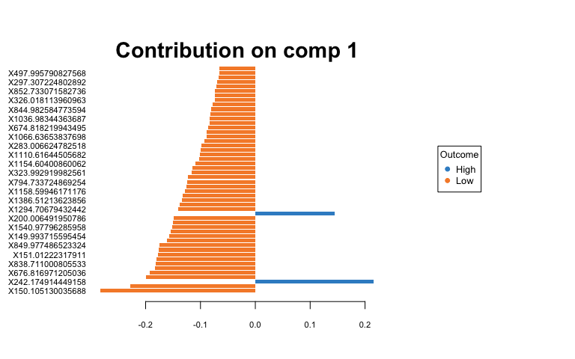

## Heatmaps of Averaged Data

1. Create averaged metabolite matrices and rerun PLS-DA to create a heatmap.

## Old Leaves  
av_Y_old <- aggregate(Y_old, by = list(class$Water, class$Fungus),   
 FUN = "mean", simplify = T, data = class)  
av.old.plsda <- mixOmics::plsda(av_Y_old[, 3:3735], av_Y_old$Group.1) # water  
  
# heatmap  
oldcim <- cim(av.old.plsda, title = "Old Leaf Secondary Met. (neg) Averaged Over Water",   
 col.names = F, xlab = "Secondary Metabolites", save = "png",   
 name.save = "~/Box/Summer 2018 TX Endo Field Samples and Analysis/Statistics/Kenia_Thesis_Analysis/Secondary Metabolites Statistics/old_water_avsmneg_hm.png") # by water treatment  
  
## Young Leaves  
av_Y_young <- aggregate(Y_young, by = list(class$Water, class$Fungus),   
 FUN = "mean", simplify = T, data = class)  
av.young.plsda <- mixOmics::plsda(av_Y_young[, 3:2566], av_Y_young$Group.1) # water  
av.young.plsda2 <- mixOmics::plsda(av_Y_young[, 3:2566], av_Y_young$Group.2) # fungus  
  
# heatmap  
youngcim <- cim(av.young.plsda, title = "Young Leaf Secondary Met. (neg) Averaged Over Water",   
 col.names = F, xlab = "Secondary Metabolites", save = "png",   
 name.save = "~/Box/Summer 2018 TX Endo Field Samples and Analysis/Statistics/Kenia_Thesis_Analysis/Secondary Metabolites Statistics/young_water_avsmneg_hm.png") # by water treatment  
  
# heatmap  
youngcim2 <- cim(av.young.plsda2, title = "Young Leaf Secondary Met. (neg) Averaged Over Fungi",   
 col.names = F, xlab = "Secondary Metabolites", save = "png",   
 name.save = "~/Box/Summer 2018 TX Endo Field Samples and Analysis/Statistics/Kenia_Thesis_Analysis/Secondary Metabolites Statistics/young_fungus_avsmneg_hm.png") # by fungal treatment

## Indicator Analysis

1. Identify indicator metabolites characteristic of each treatment using Dufrene-Legendre Indicator Analysis.

# Old Leaf  
indicator_WaterO <- indval(Y_old, clustering = class$Water, numitr = 999,   
 type = "long")  
summary(indicator_WaterO)

##   
## Sum of probabilities = 867   
##   
## Sum of Indicator Values = 2138   
##   
## Sum of Significant Indicator Values = 1055.66   
##   
## Number of Significant Indicators = 1694   
##   
## Significant Indicator Distribution  
##   
## 1 2   
## 111 1583

# Young Leaf  
indicator_Water <- indval(Y_young, clustering = class$Water,   
 numitr = 999, type = "long")  
indicator_Fungus <- indval(Y_young, clustering = class$Fungus,   
 numitr = 999, type = "long")  
summary(indicator_Water)

##   
## Sum of probabilities = 708.017017017017   
##   
## Sum of Indicator Values = 1526.49   
##   
## Sum of Significant Indicator Values = 718.99   
##   
## Number of Significant Indicators = 1081   
##   
## Significant Indicator Distribution  
##   
## 1 2   
## 469 612

summary(indicator_Fungus)

## cluster indicator_value probability  
## X126.978565369291 2 0.1961 0.023023023  
## X174.955281450343 3 0.1998 0.032032032  
## X362.876199428467 3 0.1721 0.043043043  
## X732.753622137795 3 0.1641 0.017017017  
## X570.842116351837 3 0.1436 0.044044044  
## X719.973261950079 4 0.3228 0.015015015  
## X755.203385793584 4 0.2732 0.046046046  
## X114.935142929173 4 0.2214 0.018018018  
## X290.987559951518 4 0.2110 0.033033033  
## X297.965942084671 4 0.2017 0.017017017  
## X506.971749443834 4 0.2013 0.032032032  
## X1016.95098645776 4 0.1952 0.047047047  
## X300.152669002914 4 0.1832 0.034034034  
## X174.95528178745 4 0.1823 0.047047047  
## X157.998103785124 4 0.1790 0.043043043  
## X451.856709396092 4 0.1570 0.031031031  
## X288.935299439552 4 0.1514 0.011011011  
## X442.893065530899 4 0.1462 0.036036036  
## X150.914649588063 4 0.1432 0.040040040  
## X672.776584033332 4 0.1426 0.048048048  
## X399.13009701304 5 0.2728 0.018018018  
## X582.182538128675 5 0.2635 0.019019019  
## X561.235165916746 5 0.2544 0.043043043  
## X439.157916063253 5 0.2198 0.017017017  
## X596.203846215805 5 0.2053 0.028028028  
## X462.168292694096 5 0.2049 0.021021021  
## X791.274337542169 5 0.2033 0.024024024  
## X415.159188680521 5 0.1996 0.048048048  
## X461.164714419708 5 0.1995 0.040040040  
## X616.22881415752 5 0.1966 0.034034034  
## X595.199358972177 5 0.1941 0.011011011  
## X793.288299990309 5 0.1907 0.035035035  
## X443.115738244395 5 0.1835 0.039039039  
## X375.127006310969 5 0.1786 0.035035035  
## X376.129076720164 5 0.1762 0.024024024  
## X438.12133847032 5 0.1670 0.035035035  
## X170.867102638045 7 0.1541 0.034034034  
## X177.038796119533 8 0.2596 0.003003003  
## X207.05046346149 9 0.2156 0.028028028  
##   
## Sum of probabilities = 1536.1021021021   
##   
## Sum of Indicator Values = 445.52   
##   
## Sum of Significant Indicator Values = 7.73   
##   
## Number of Significant Indicators = 39   
##   
## Significant Indicator Distribution  
##   
## 2 3 4 5 7 8 9   
## 1 4 15 16 1 1 1

1. Disect indval object and export results to a csv file.

Orelfrq <- indicator_WaterO$relfrq # relative frequency of species in classes  
Orelabu <- indicator_WaterO$relabu # relative abundance of species in classes  
Oindval <- indicator_WaterO$indval # the indicator value for each species  
Omaxcls <- data.frame(indicator_WaterO$maxcls) # the class each species has max indicator value for  
Oindcls <- data.frame(indicator_WaterO$indcls) # the indicator value for each species to its max class  
Opval <- data.frame(indicator_WaterO$pval) # the probability of obtaining as high an indicator value as observed over the specified iterations  
  
write.csv(cbind(Orelfrq, Orelabu, Oindval, Omaxcls, Oindcls,   
 Opval), "~/Box/Summer 2018 TX Endo Field Samples and Analysis/Statistics/Kenia_Thesis_Analysis/Secondary Metabolites Statistics/Indicator_Analys_oSMneg_Water.csv")  
  
Yrelfrq <- indicator_Water$relfrq # relative frequency of species in classes  
Yrelabu <- indicator_Water$relabu # relative abundance of species in classes  
Yindval <- indicator_Water$indval # the indicator value for each species  
Ymaxcls <- data.frame(indicator_Water$maxcls) # the class each species has max indicator value for  
Yindcls <- data.frame(indicator_Water$indcls) # the indicator value for each species to its max class  
Ypval <- data.frame(indicator_Water$pval) # the probability of obtaining as high an indicator value as observed over the specified iterations  
  
write.csv(cbind(Yrelfrq, Yrelabu, Yindval, Ymaxcls, Yindcls,   
 Ypval), "~/Box/Summer 2018 TX Endo Field Samples and Analysis/Statistics/Kenia_Thesis_Analysis/Secondary Metabolites Statistics/Indicator_Analys_ySMneg_Water.csv")  
  
relfrq <- indicator_Fungus$relfrq # relative frequency of species in classes  
relabu <- indicator_Fungus$relabu # relative abundance of species in classes  
indval <- indicator_Fungus$indval # the indicator value for each species  
maxcls <- data.frame(indicator_Fungus$maxcls) # the class each species has max indicator value for  
indcls <- data.frame(indicator_Fungus$indcls) # the indicator value for each species to its max class  
pval <- data.frame(indicator_Fungus$pval) # the probability of obtaining as high an indicator value as observed over the specified iterations  
  
write.csv(cbind(relfrq, relabu, indval, maxcls, indcls, pval),   
 "~/Box/Summer 2018 TX Endo Field Samples and Analysis/Statistics/Kenia_Thesis_Analysis/Secondary Metabolites Statistics/Indicator_Analys_ySMneg_Fungus.csv")

# Secondary Metabolites (Pos)

## RRPP

1. Define dependent variable matrix and class matrix.

path <- "~/Box/Summer 2018 TX Endo Field Samples and Analysis/Statistics/Kenia_Thesis_Analysis/"  
  
O_SM_pos <- read_tsv(paste(path, "XCMS Online Results/O_SM_Pos/XCMS.annotated.Report_1394418.tsv",   
 sep = ""))  
  
Y_SM_pos <- read_tsv(paste(path, "XCMS Online Results/Y_SM_Pos/XCMS.annotated.Report_1394440.tsv",   
 sep = ""))  
  
# dependent variable: metabolite intensities  
Y_old <- O_SM_pos[, c(2, 12:54)] %>% data.frame(row.names = 1) %>%   
 t %>% data.frame()  
scaled_Y_old <- scale(Y_old)  
  
Y_young <- Y_SM_pos[, c(2, 12:54)] %>% data.frame(row.names = 1) %>%   
 t %>% data.frame()  
scaled_Y_young <- scale(Y_young)  
  
# class: sample factors  
class <- read.csv(paste(path, "XCMS Online Results/class.csv",   
 sep = ""), header = T, row.names = 1)

1. Define and run multivariate regression models, then print out the results.

O_LMpos <- lm.rrpp(scaled_Y_old ~ Block * Water * Fungus, data = class,   
 SS.type = "III", print.progress = F)  
summary(O_LMpos)

##   
## Linear Model fit with lm.rrpp  
##   
## Number of observations: 43  
## Number of dependent variables: 5800   
## Data space dimensions: 42   
## Sums of Squares and Cross-products: Type III  
## Number of permutations: 1000  
##   
## Full Model Analysis of Variance  
##   
## Df Residual Df SS Residual SS Rsq F  
## Block * Water * Fungus 7 35 66102.35 177497.7 0.2713561 1.862063  
## Z (from F) Pr(>F)  
## Block * Water * Fungus 3.745304 0.0005714286  
##   
##   
## Redundancy Analysis (PCA on fitted values and residuals)  
##   
## Trace Proportion Rank  
## Fitted 1573.865 0.271356 7  
## Residuals 4226.135 0.728644 35  
## Total 5800.000 1.000000 42  
##   
## Eigenvalues  
##   
## PC1 PC2 PC3 PC4 PC5 PC6 PC7  
## Fitted 613.0058 377.3605 245.4204 108.9341 90.8147 75.5811 62.7487  
## Residuals 1125.9274 456.5069 301.3978 228.3176 221.2095 152.5997 143.8765  
## Total 1563.9592 668.0796 447.6527 365.5013 244.1181 236.9154 180.9496  
## PC8 PC9 PC10 PC11 PC12 PC13 PC14  
## Fitted   
## Residuals 138.6110 120.4927 105.6991 100.1973 86.5102 79.7117 76.6642  
## Total 164.0427 148.5100 136.1229 116.6738 109.9659 96.2741 89.0995  
## PC15 PC16 PC17 PC18 PC19 PC20 PC21  
## Fitted   
## Residuals 71.8936 67.2005 61.6455 60.0418 56.5602 54.0174 51.0623  
## Total 84.0573 78.2452 75.8352 68.1756 62.8428 61.6040 59.1024  
## PC22 PC23 PC24 PC25 PC26 PC27 PC28  
## Fitted   
## Residuals 49.5758 45.6077 44.4495 42.9826 38.1437 35.0037 32.8700  
## Total 56.0853 53.7059 49.4072 48.9840 46.9481 46.5683 43.3817  
## PC29 PC30 PC31 PC32 PC33 PC34 PC35  
## Fitted   
## Residuals 32.0639 28.5369 27.4785 24.8828 23.9346 21.1897 19.2722  
## Total 41.0579 37.8943 34.1106 32.7965 31.8990 29.7583 28.4563  
## PC36 PC37 PC38 PC39 PC40 PC41 PC42  
## Fitted   
## Residuals   
## Total 26.1381 25.2956 24.1190 24.0956 22.7724 20.3350 18.4638

Y_LMpos <- lm.rrpp(scaled_Y_young ~ Block * Water * Fungus, data = class,   
 SS.type = "III", print.progress = F)  
summary(Y_LMpos)

##   
## Linear Model fit with lm.rrpp  
##   
## Number of observations: 43  
## Number of dependent variables: 3559   
## Data space dimensions: 42   
## Sums of Squares and Cross-products: Type III  
## Number of permutations: 1000  
##   
## Full Model Analysis of Variance  
##   
## Df Residual Df SS Residual SS Rsq F  
## Block * Water * Fungus 7 35 38642.68 110835.3 0.2585175 1.743248  
## Z (from F) Pr(>F)  
## Block * Water * Fungus 3.399081 0.001571429  
##   
##   
## Redundancy Analysis (PCA on fitted values and residuals)  
##   
## Trace Proportion Rank  
## Fitted 920.064 0.2585176 7  
## Residuals 2638.936 0.7414824 35  
## Total 3559.000 1.0000000 42  
##   
## Eigenvalues  
##   
## PC1 PC2 PC3 PC4 PC5 PC6 PC7  
## Fitted 397.7443 240.1652 87.8892 66.1666 47.2456 44.1174 36.7354  
## Residuals 633.3110 249.1598 226.5129 162.1190 123.8237 98.7414 86.2987  
## Total 812.6211 580.6484 274.7611 195.5419 135.8900 111.6667 91.3427  
## PC8 PC9 PC10 PC11 PC12 PC13 PC14  
## Fitted   
## Residuals 74.0692 62.7979 62.2331 54.0214 50.0254 49.2183 47.9739  
## Total 81.8073 74.4560 68.9230 65.8313 58.9405 52.9731 51.5130  
## PC15 PC16 PC17 PC18 PC19 PC20 PC21  
## Fitted   
## Residuals 46.9945 42.0306 40.1348 39.0245 37.6032 36.6949 35.0499  
## Total 49.3036 48.1786 45.4179 43.1774 42.9165 40.3182 39.0791  
## PC22 PC23 PC24 PC25 PC26 PC27 PC28  
## Fitted   
## Residuals 33.5945 32.0128 31.2296 30.3538 29.6785 28.2886 27.7751  
## Total 37.6835 35.9477 35.1338 33.9837 33.6972 32.1289 31.3560  
## PC29 PC30 PC31 PC32 PC33 PC34 PC35  
## Fitted   
## Residuals 27.0825 26.2620 25.4541 24.0211 23.4611 22.1253 19.7593  
## Total 30.5374 29.9458 28.8928 28.0758 27.1667 26.5044 26.1782  
## PC36 PC37 PC38 PC39 PC40 PC41 PC42  
## Fitted   
## Residuals   
## Total 25.4687 25.1620 23.5154 22.1223 21.2005 19.9071 19.0846

1. Examine RRPP plots to check for assumptions.

## Old Leaves residuals vs fitted values (homoscedasticity  
## check)  
Odiagnostics <- plot(O_LMpos, type = "diagnostics")

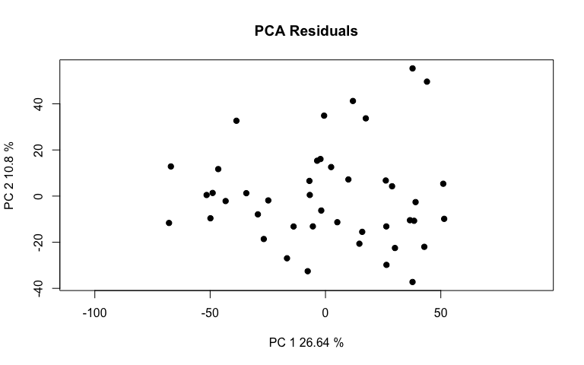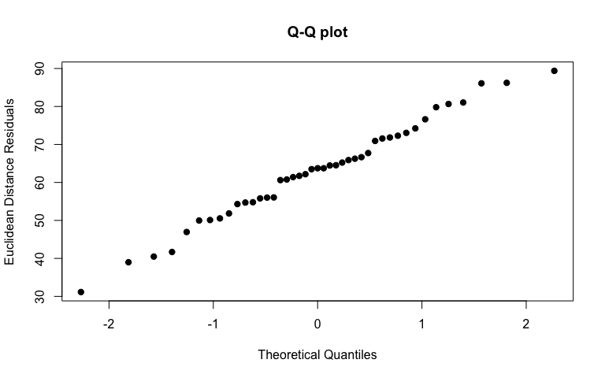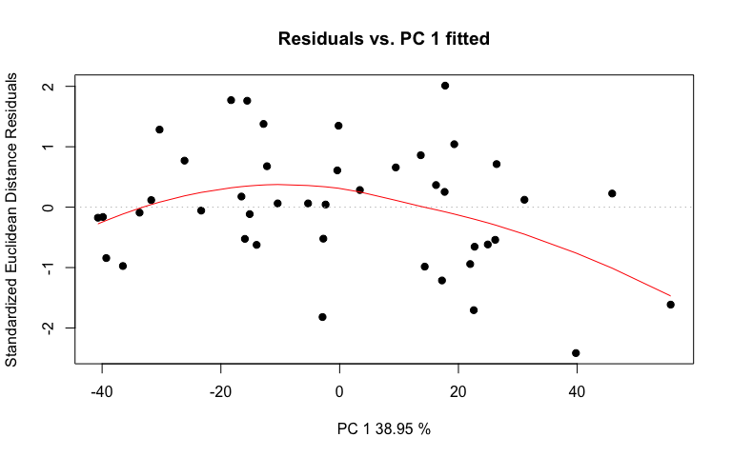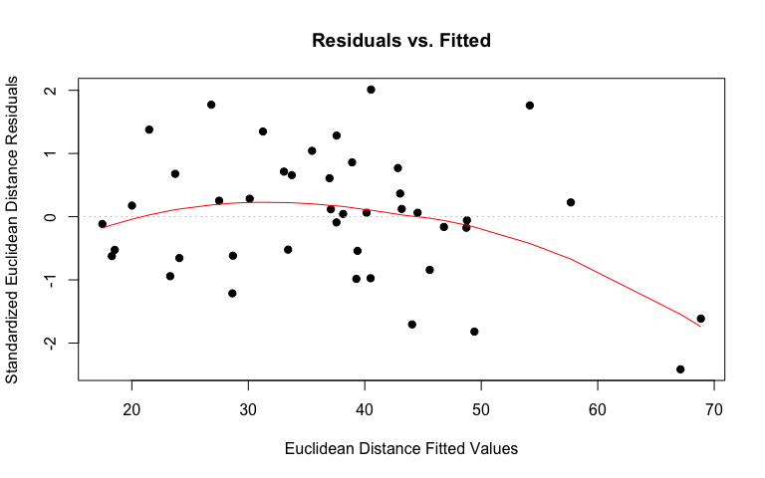

# linear regression plot  
Oregression <- plot(O_LMpos, type = "regression", predictor = class$Fungus,   
 reg.type = "RegScore")

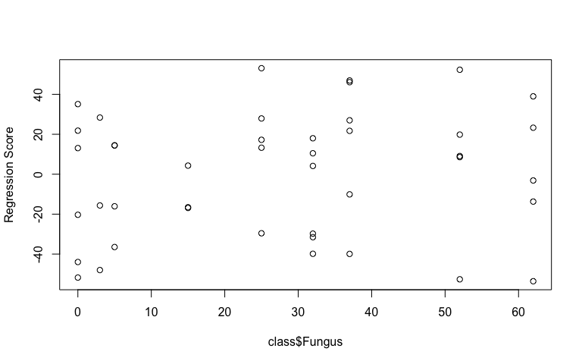

# pca plot  
Opcplot <- plot(O_LMpos, type = "PC", pch = 19, col = interaction(class$Water,   
 class$Fungus))

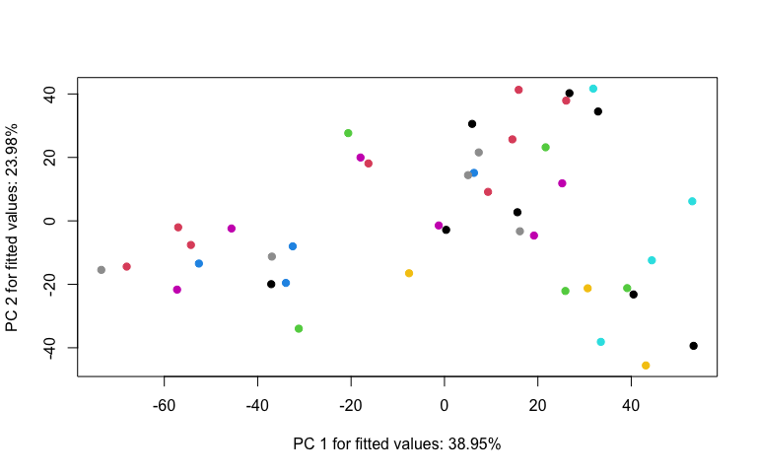

## Young Leaves residuals vs fitted values (homoscedasticity  
## check)  
Ydiagnostics <- plot(Y_LMpos, type = "diagnostics")

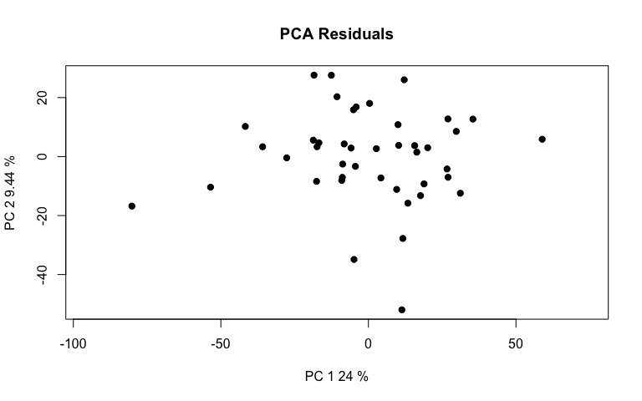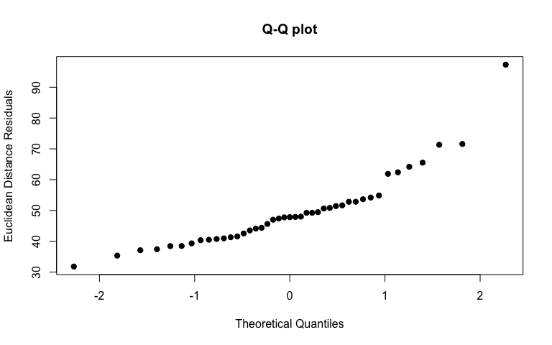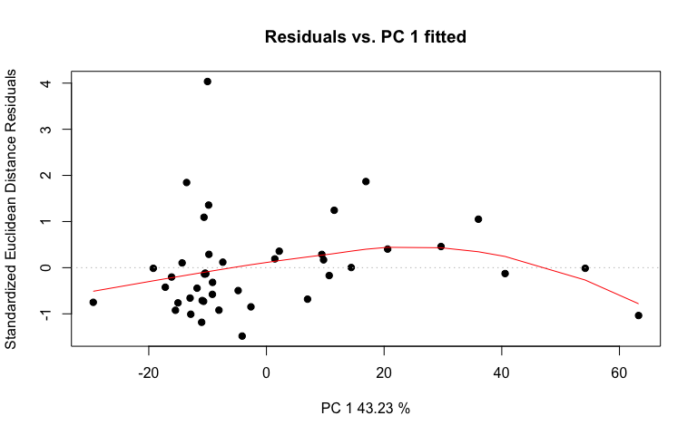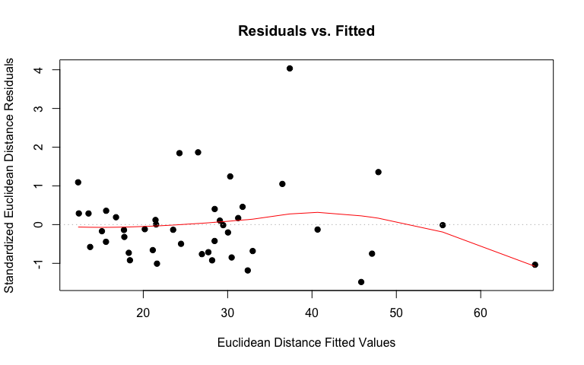

# linear regression plot  
Yregression <- plot(Y_LMpos, type = "regression", predictor = class$Fungus,   
 reg.type = "RegScore")

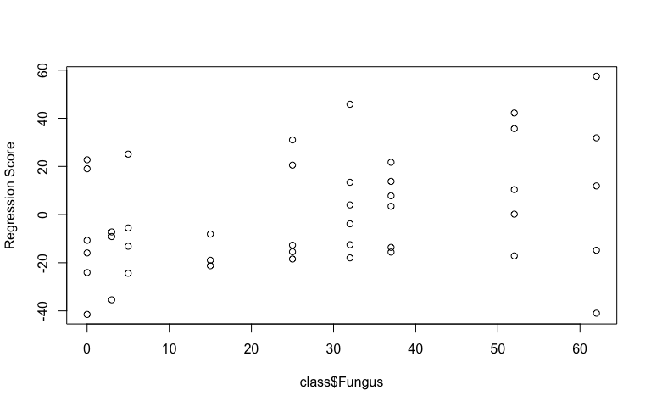

# pca plot  
Ypcplot <- plot(Y_LMpos, type = "PC", pch = 19, col = interaction(class$Water,   
 class$Fungus))

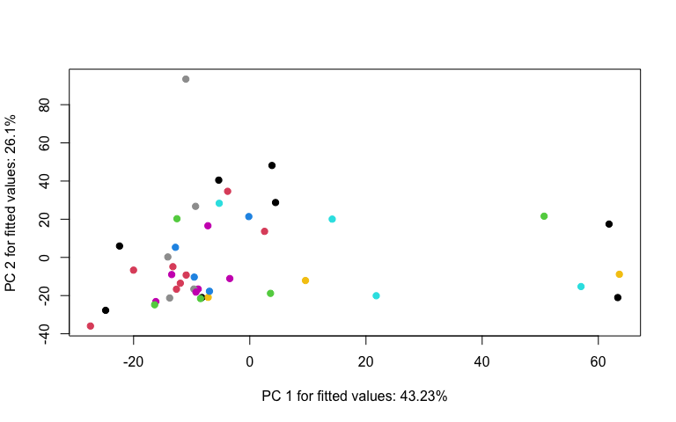

1. Perform an RRPP ANOVA and print results.

## Old Leaves  
OposANOVA <- anova(O_LMpos, effect.type = "F", error = c("Residuals",   
 "Block:Water", "Block:Water:Fungus", "Residuals", "Block:Water:Fungus",   
 "Block:Water:Fungus", "Residuals"))  
summary(OposANOVA, formula = T)

##   
## Analysis of Variance, using Residual Randomization  
## Permutation procedure: Randomization of null model residuals   
## Number of permutations: 1000   
## Estimation method: Ordinary Least Squares   
## Sums of Squares and Cross-products: Type III   
## Effect sizes (Z) based on F distributions  
##   
## Df SS MS Rsq F Z Pr(>F)   
## Block 1 9842 9842.3 0.04040 1.9408 1.93563 0.043 *  
## Water 1 6015 6014.6 0.02469 1.2215 0.96850 0.174   
## Fungus 1 8415 8414.6 0.03454 1.9912 1.74049 0.044 *  
## Block:Water 1 4924 4923.9 0.02021 0.9709 0.06545 0.428   
## Block:Fungus 1 7570 7569.9 0.03108 1.7913 1.68520 0.044 *  
## Water:Fungus 1 4625 4625.0 0.01899 1.0944 0.39905 0.352   
## Block:Water:Fungus 1 4226 4225.9 0.01735 0.8333 -0.37299 0.607   
## Residuals 35 177498 5071.4 0.72864   
## Total 42 243600   
## ---  
## Signif. codes: 0 '***' 0.001 '**' 0.01 '*' 0.05 '.' 0.1 ' ' 1  
##   
## Call: lm.rrpp(f1 = scaled_Y_old ~ Block * Water * Fungus, SS.type = "III",   
## data = class, print.progress = F)

## Young Leaves  
YposANOVA <- anova(Y_LMpos, effect.type = "F", error = c("Residuals",   
 "Block:Water", "Block:Water:Fungus", "Residuals", "Block:Water:Fungus",   
 "Block:Water:Fungus", "Residuals"))  
summary(YposANOVA, formula = T)

##   
## Analysis of Variance, using Residual Randomization  
## Permutation procedure: Randomization of null model residuals   
## Number of permutations: 1000   
## Estimation method: Ordinary Least Squares   
## Sums of Squares and Cross-products: Type III   
## Effect sizes (Z) based on F distributions  
##   
## Df SS MS Rsq F Z Pr(>F)   
## Block 1 5774 5773.8 0.03863 1.8233 1.91902 0.045 *  
## Water 1 3326 3325.5 0.02225 0.8231 -0.92641 0.828   
## Fungus 1 7286 7285.7 0.04874 1.4310 0.95467 0.155   
## Block:Water 1 4040 4040.2 0.02703 1.2758 0.91450 0.161   
## Block:Fungus 1 6299 6299.0 0.04214 1.2372 0.61786 0.247   
## Water:Fungus 1 3839 3839.1 0.02568 0.7540 -1.29822 0.913   
## Block:Water:Fungus 1 5091 5091.4 0.03406 1.6078 1.57153 0.088 .  
## Residuals 35 110835 3166.7 0.74148   
## Total 42 149478   
## ---  
## Signif. codes: 0 '***' 0.001 '**' 0.01 '*' 0.05 '.' 0.1 ' ' 1  
##   
## Call: lm.rrpp(f1 = scaled_Y_young ~ Block * Water * Fungus, SS.type = "III",   
## data = class, print.progress = F)

1. Test lm.rrpp model coefficients. “d” is the amount of change in a variable for the coefficient indicated.

## Old Leaves test model coefficients  
Oposcoef <- coef(O_LMpos, test = T)  
summary(Oposcoef)

##   
## Linear Model fit with lm.rrpp  
##   
## Number of observations: 43  
## Number of dependent variables: 5800  
## Data space dimensions: 42  
## Sums of Squares and Cross-products: Type III  
## Number of permutations: 1000  
##   
## Statistics (distances) of coefficients with 95 percent confidence intervals,  
## effect sizes, and probabilities of exceeding observed values based on  
## 1000 random permutations using RRPP   
##   
## d.obs UCL (95%) Zd Pr(>d)  
## (Intercept) 82.950278 121.985522 -0.9656612 0.830  
## Block 47.308227 42.862108 2.6530050 0.018  
## WaterLow 95.740528 108.500604 1.0580682 0.133  
## Fungus 2.409128 2.387798 2.0517450 0.047  
## Block:WaterLow 44.635517 56.517070 0.4231836 0.266  
## Block:Fungus 1.171821 1.211972 1.6991995 0.071  
## WaterLow:Fungus 2.477853 3.166755 0.2264772 0.354  
## Block:WaterLow:Fungus 1.171555 1.616995 -0.0172714 0.426

## Young Leaves test model coefficients  
Yposcoef <- coef(Y_LMpos, test = T)  
summary(Yposcoef)

##   
## Linear Model fit with lm.rrpp  
##   
## Number of observations: 43  
## Number of dependent variables: 3559  
## Data space dimensions: 42  
## Sums of Squares and Cross-products: Type III  
## Number of permutations: 1000  
##   
## Statistics (distances) of coefficients with 95 percent confidence intervals,  
## effect sizes, and probabilities of exceeding observed values based on  
## 1000 random permutations using RRPP   
##   
## d.obs UCL (95%) Zd Pr(>d)  
## (Intercept) 67.224931 86.6097468 -0.2926484 0.560  
## Block 36.234157 33.0439840 2.6250965 0.026  
## WaterLow 71.190457 85.0930030 0.7408915 0.184  
## Fungus 2.241702 1.8664608 3.4234113 0.005  
## Block:WaterLow 40.431917 43.9953314 1.3804395 0.090  
## Block:Fungus 1.068939 0.9499183 2.8673697 0.016  
## WaterLow:Fungus 2.257521 2.4969515 1.1822329 0.129  
## Block:WaterLow:Fungus 1.285945 1.2558817 2.2174577 0.039

Block and Fungus have the largest effect on the model for old leaves, but not their interaction. The standard is the mean for High water treatment. For young leaves, Block, Fungus, Block:Fungus, and Block:WaterLow:Fungus have the largest effect on the model.

1. Compute predicted values from the lm.rrpp model fit using bootstrapped residuals to generate confidence intervals (precision of group mean estimates).

O_pred <- predict(O_LMpos)  
plot(O_pred, PC = T, ellipse = T)

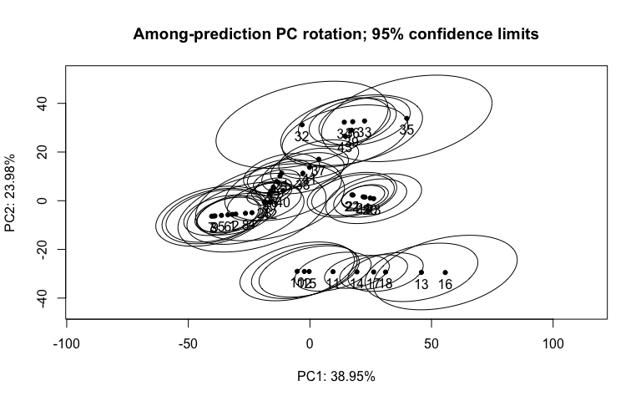

Y_pred <- predict(Y_LMpos)  
plot(Y_pred, PC = T, ellipse = T)

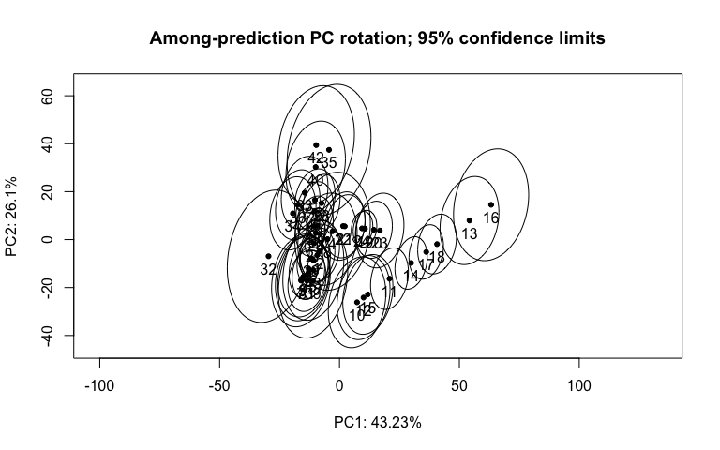

1. Test pairwise differences between least squares means. Similar to tukeyHSD function in the r stats package. The pairwise function will generate tables with confidence intervals and p‐values for the pairwise statistic, Euclidean distance between least‐squares means.

## Old Leaves pairwise differences of fungus  
Opospw <- pairwise(O_LMpos, groups = class$Fungus)  
summary(Opospw, confidence = 0.95, stat.table = T)

##   
## Pairwise comparisons  
##   
## Groups: 0 3 5 15 25 32 37 52 62   
##   
## RRPP: 1000 permutations  
##   
## LS means:  
## Vectors hidden (use show.vectors = TRUE to view)  
##   
## Pairwise distances between means, plus statistics  
## d UCL (95%) Z Pr > d  
## 0:3 22.190429 32.595628 -1.0363762 0.855  
## 0:5 17.798195 27.382869 -0.6216817 0.685  
## 0:15 24.519599 35.503011 -0.7383296 0.735  
## 0:25 13.615879 23.329685 -1.7071115 0.989  
## 0:32 16.139136 27.683841 -2.1297186 0.999  
## 0:37 18.660876 32.009442 -2.1297186 0.999  
## 0:52 29.207175 48.094881 -1.8235328 0.988  
## 0:62 31.133050 53.016598 -2.2578357 1.000  
## 3:5 17.786466 27.649058 -2.4409760 1.000  
## 3:15 12.322880 20.954505 -1.8739528 0.998  
## 3:25 22.264469 32.751009 -1.8759385 0.994  
## 3:32 24.176171 36.230015 -1.7347681 0.986  
## 3:37 25.415180 38.428930 -1.9047376 0.994  
## 3:52 30.040035 46.896491 -2.2945570 1.000  
## 3:62 35.208499 55.712597 -2.1353313 0.999  
## 5:15 12.706131 19.039764 -1.6275339 0.978  
## 5:25 15.112813 23.916840 -1.5967148 0.978  
## 5:32 19.099319 30.150213 -1.5400493 0.973  
## 5:37 20.477870 32.715432 -1.7831798 0.989  
## 5:52 27.654743 43.338550 -2.0241162 0.995  
## 5:62 31.206660 50.890285 -2.0874857 0.996  
## 15:25 19.500368 27.175373 -0.8392479 0.782  
## 15:32 22.187833 31.320643 -0.8590205 0.784  
## 15:37 22.854770 32.866767 -1.0275958 0.843  
## 15:52 25.865764 38.786671 -1.6016917 0.979  
## 15:62 31.688647 48.856164 -1.5866827 0.976  
## 25:32 5.003006 7.918074 -1.5516400 0.966  
## 25:37 6.857942 11.202856 -2.0733970 0.996  
## 25:52 17.391686 26.832045 -1.6677330 0.961  
## 25:62 19.775068 33.336462 -2.2183112 0.999  
## 32:37 2.521740 4.325600 -2.1297186 0.999  
## 32:52 14.379824 22.337418 -1.4140734 0.940  
## 32:62 15.526671 26.660486 -2.2842883 0.999  
## 37:52 12.363495 18.849090 -1.2765064 0.917  
## 37:62 13.204385 22.539244 -2.2663387 0.999  
## 52:62 11.324188 19.564326 -1.6802913 0.988

## Young Leaves pairwise differences of fungus  
Ypospw <- pairwise(Y_LMpos, groups = class$Fungus)  
summary(Ypospw, confidence = 0.95, stat.table = T)

##   
## Pairwise comparisons  
##   
## Groups: 0 3 5 15 25 32 37 52 62   
##   
## RRPP: 1000 permutations  
##   
## LS means:  
## Vectors hidden (use show.vectors = TRUE to view)  
##   
## Pairwise distances between means, plus statistics  
## d UCL (95%) Z Pr > d  
## 0:3 12.197518 19.548605 -2.21426609 1.000  
## 0:5 12.541925 17.225178 -0.47283484 0.654  
## 0:15 12.091486 19.987403 -2.36695288 1.000  
## 0:25 10.411956 20.263874 -1.65552803 0.999  
## 0:32 14.320542 26.602293 -1.45327257 0.979  
## 0:37 16.558127 30.758901 -1.45327257 0.979  
## 0:52 27.084454 44.050817 -1.07373045 0.876  
## 0:62 28.135960 51.703487 -1.50946116 0.984  
## 3:5 13.070454 20.318975 -1.87146016 0.999  
## 3:15 7.883536 14.583644 -3.11617956 1.000  
## 3:25 16.269685 27.130362 -1.49774738 0.970  
## 3:32 18.616016 31.117053 -1.31890013 0.929  
## 3:37 20.359490 34.288275 -1.30481590 0.932  
## 3:52 28.906708 46.012589 -0.94479866 0.825  
## 3:62 30.000546 52.384649 -1.37704057 0.960  
## 5:15 9.303381 13.134942 -0.84737414 0.790  
## 5:25 18.191487 24.199294 0.03175081 0.466  
## 5:32 21.913465 29.918287 -0.13703125 0.515  
## 5:37 23.826525 33.358293 -0.25533576 0.566  
## 5:52 33.680353 45.827215 -0.12074749 0.509  
## 5:62 33.745873 51.622886 -0.71636918 0.737  
## 15:25 14.077529 20.419563 -0.73636931 0.748  
## 15:32 16.806159 24.627849 -0.68351024 0.727  
## 15:37 18.460367 27.436876 -0.72360147 0.741  
## 15:52 26.902869 38.154578 -0.38098664 0.604  
## 15:62 27.791185 44.895936 -1.01504849 0.825  
## 25:32 4.657594 7.335702 -1.02140225 0.847  
## 25:37 6.722654 11.152621 -1.14600448 0.894  
## 25:52 17.852807 25.754944 -0.55041928 0.681  
## 25:62 18.564809 32.818300 -1.42451606 0.965  
## 32:37 2.237585 4.156608 -1.45327257 0.979  
## 32:52 13.890120 19.957496 -0.51957622 0.659  
## 32:62 14.160482 25.826805 -1.56487272 0.989  
## 37:52 12.062830 16.549363 -0.31644760 0.583  
## 37:62 12.050231 21.844793 -1.58476970 0.989  
## 52:62 9.354537 16.054715 -1.53544059 0.997

## PCA

1. Identify the major source of variation in data and determine if the variation is sourced from experimental bias or biological conditions.

# Old Leaf Secondary Metabolites (Pos) tune how many  
# components to use  
tune.pca(scaled_Y_old)

## Eigenvalues for the first 10 principal components, see object$sdev^2:   
## PC1 PC2 PC3 PC4 PC5 PC6 PC7 PC8   
## 1563.9592 668.0796 447.6527 365.5013 244.1181 236.9154 180.9496 164.0427   
## PC9 PC10   
## 148.5100 136.1229   
##   
## Proportion of explained variance for the first 10 principal components, see object$explained_variance:   
## PC1 PC2 PC3 PC4 PC5 PC6 PC7   
## 0.26964813 0.11518614 0.07718151 0.06301746 0.04208933 0.04084749 0.03119821   
## PC8 PC9 PC10   
## 0.02828322 0.02560518 0.02346946   
##   
## Cumulative proportion explained variance for the first 10 principal components, see object$cum.var:   
## PC1 PC2 PC3 PC4 PC5 PC6 PC7 PC8   
## 0.2696481 0.3848343 0.4620158 0.5250332 0.5671226 0.6079701 0.6391683 0.6674515   
## PC9 PC10   
## 0.6930567 0.7165261   
##   
## Other available components:   
## --------------------   
## loading vectors: see object$rotation

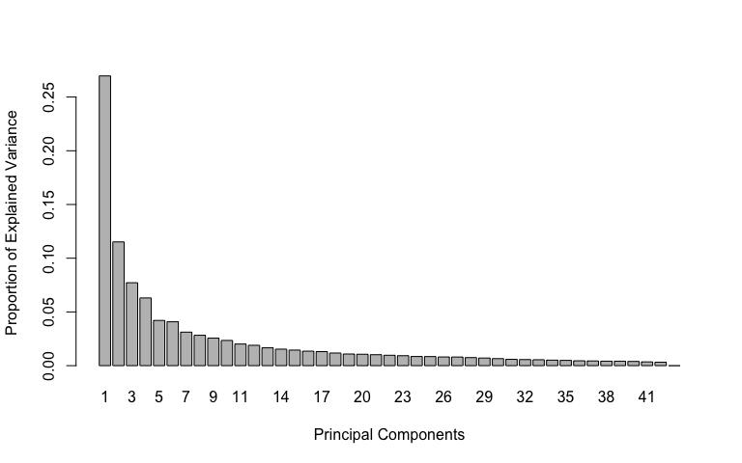

pca.res <- mixOmics::pca(scaled_Y_old, ncomp = 3, scale = F)  
  
# plot pca  
plotIndiv(pca.res, group = class$Fungus, ind.names = F, pch = as.factor(class$Water),   
 legend = T, legend.title = "Fungus", legend.title.pch = "Water",   
 title = "Old Leaf Secondary Metabolites (Pos) PCA")

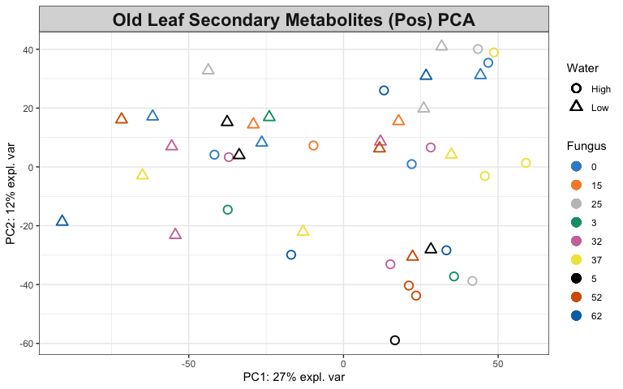

# Look at variable coefficients in each component with the  
# loading vectors The absolute value of loading vectors  
# represent the importance of each variable to define each PC  
plotLoadings(pca.res, ndisplay = 50)

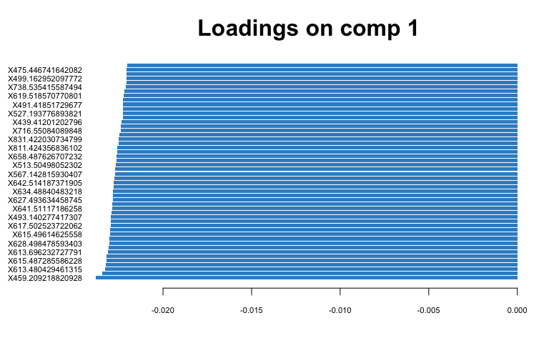

# Young Leaf Secondary Metabolites (Pos) tune how many  
# components to use  
tune.pca(scaled_Y_young)

## Eigenvalues for the first 10 principal components, see object$sdev^2:   
## PC1 PC2 PC3 PC4 PC5 PC6 PC7 PC8   
## 812.62108 580.64841 274.76111 195.54194 135.89003 111.66667 91.34267 81.80728   
## PC9 PC10   
## 74.45598 68.92299   
##   
## Proportion of explained variance for the first 10 principal components, see object$explained_variance:   
## PC1 PC2 PC3 PC4 PC5 PC6 PC7   
## 0.22832849 0.16314931 0.07720177 0.05494294 0.03818208 0.03137586 0.02566526   
## PC8 PC9 PC10   
## 0.02298603 0.02092048 0.01936583   
##   
## Cumulative proportion explained variance for the first 10 principal components, see object$cum.var:   
## PC1 PC2 PC3 PC4 PC5 PC6 PC7 PC8   
## 0.2283285 0.3914778 0.4686796 0.5236225 0.5618046 0.5931805 0.6188457 0.6418317   
## PC9 PC10   
## 0.6627522 0.6821181   
##   
## Other available components:   
## --------------------   
## loading vectors: see object$rotation

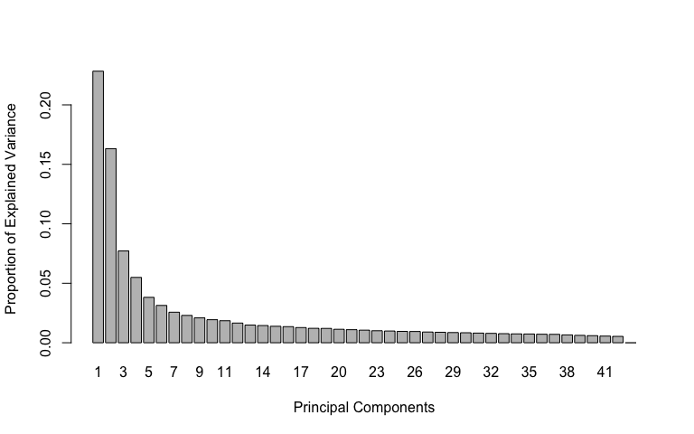

pca.res <- mixOmics::pca(scaled_Y_young, ncomp = 3, scale = F)  
  
# plot pca  
plotIndiv(pca.res, group = class$Fungus, ind.names = F, pch = as.factor(class$Water),   
 legend = T, legend.title = "Fungus", legend.title.pch = "Water",   
 title = "Young Leaf Secondary Metabolites (Pos) PCA")

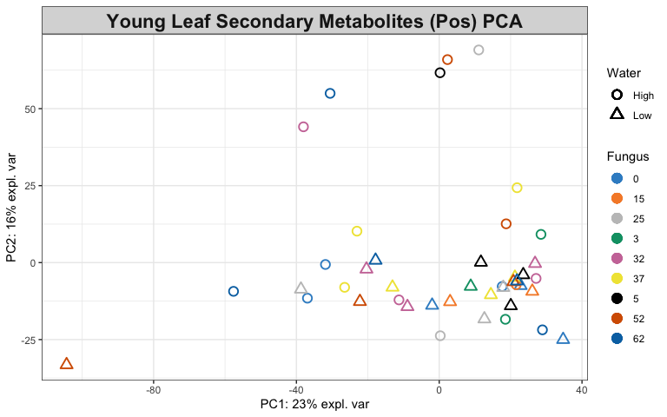

# Look at variable coefficients in each component with the  
# loading vectors The absolute value of loading vectors  
# represent the importance of each variable to define each PC  
plotLoadings(pca.res, ndisplay = 50)

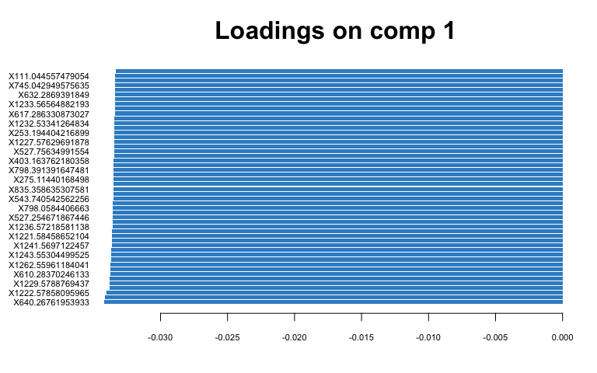

1. Identify the variables that contribute to the explained variance.

# Old Leaf  
spca.res <- mixOmics::spca(scaled_Y_old, ncomp = 3, keepX = c(100,   
 100, 10))  
  
# plot spca  
plotIndiv(spca.res, group = class$Fungus, ind.names = F, pch = as.factor(class$Water),   
 legend = T, legend.title = "Fungus", legend.title.pch = "Water",   
 title = "Old Leaf Secondary Metabolites (Pos) sPCA")

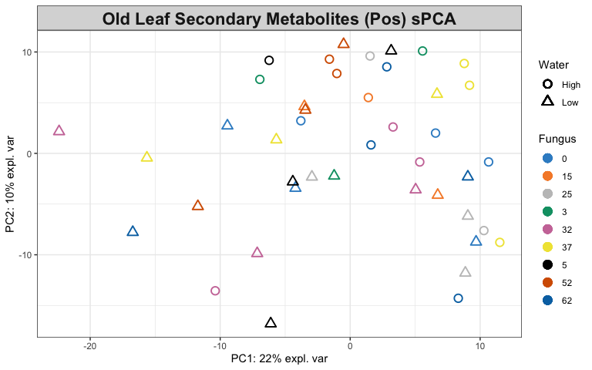

# variables contributing to each component  
plotVar(spca.res, cex = 1)

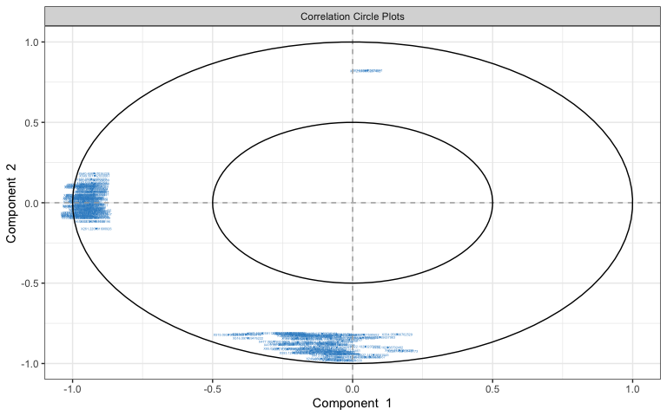

selectVar(spca.res, comp = 1)$value # view loading value of each metabolite

## value.var  
## X623.5427146501 -0.182055114  
## X622.539887164198 -0.181404088  
## X314.276975384773 -0.180391891  
## X313.273601537502 -0.177913462  
## X609.528418469459 -0.173659127  
## X593.503695335635 -0.173111385  
## X608.525125744233 -0.173085253  
## X610.530931596464 -0.170019964  
## X636.555782347412 -0.164596649  
## X617.502523722062 -0.161488471  
## X615.49614625558 -0.161372201  
## X637.554974068755 -0.160689106  
## X636.555044413109 -0.157801079  
## X616.499669547884 -0.157311441  
## X638.554170230362 -0.156500296  
## X611.543535737333 -0.154368634  
## X263.236566731675 -0.149120932  
## X650.568768355466 -0.146359898  
## X626.562565312764 -0.145730463  
## X624.554998209121 -0.144372113  
## X625.55795874975 -0.142472966  
## X575.502966681956 -0.137889376  
## X637.48032502828 -0.136679304  
## X638.483173644822 -0.135515131  
## X576.505762391681 -0.135267793  
## X618.507103088589 -0.129459479  
## X811.424356836102 -0.125604358  
## X624.546393245245 -0.119384220  
## X610.540587713529 -0.118351586  
## X633.526384652885 -0.117956330  
## X638.571010920895 -0.115276197  
## X631.50710466344 -0.113748627  
## X574.490589263477 -0.111560071  
## X601.517812801478 -0.110208018  
## X613.696232727791 -0.109824109  
## X615.487285586228 -0.108647615  
## X746.457453097686 -0.107262835  
## X743.436513200601 -0.105806758  
## X637.557509911664 -0.102124150  
## X602.521531638131 -0.097096716  
## X745.453691240662 -0.094310581  
## X585.446721188158 -0.090565970  
## X630.507793882762 -0.089309333  
## X632.524036885204 -0.087580472  
## X767.440469599277 -0.082429634  
## X617.723248632496 -0.082259964  
## X595.507447349485 -0.079387805  
## X635.464542075429 -0.079367125  
## X643.526311756535 -0.078010992  
## X613.480429461315 -0.076824176  
## X659.48872253972 -0.076643589  
## X577.506622179924 -0.075085714  
## X614.48413993025 -0.071693614  
## X645.515984064549 -0.071351379  
## X651.564511662028 -0.069707813  
## X636.467534222444 -0.069163816  
## X626.570188705153 -0.065764285  
## X573.487260848141 -0.065535248  
## X829.406046163401 -0.062453335  
## X658.538868443561 -0.060418449  
## X580.492441620954 -0.059736350  
## X641.51117186258 -0.058555426  
## X642.514187371905 -0.058042934  
## X659.537339659066 -0.058033262  
## X768.443158772313 -0.055913361  
## X598.456409633744 -0.055656048  
## X664.585958751482 -0.053832451  
## X652.58279371971 -0.053087021  
## X643.514428788009 -0.052008040  
## X673.509123378608 -0.051285990  
## X331.283812280979 -0.045554142  
## X644.529496767651 -0.045034037  
## X657.484442714608 -0.043683074  
## X667.525186185759 -0.042049347  
## X660.503817215267 -0.038786678  
## X633.484726945181 -0.037949634  
## X658.487626707232 -0.037612021  
## X744.439887639683 -0.036573902  
## X663.551426151608 -0.035986321  
## X665.510410370928 -0.035924141  
## X665.586601431923 -0.034656733  
## X644.514172333257 -0.033719869  
## X666.546022519191 -0.032138035  
## X662.551874509279 -0.031995479  
## X639.565404224584 -0.029863137  
## X620.52328522026 -0.025732640  
## X668.53044299629 -0.025132634  
## X645.530094137731 -0.024834541  
## X640.498767036228 -0.022619778  
## X600.503635384639 -0.021720501  
## X599.501142033087 -0.018378543  
## X638.57096397224 -0.017188350  
## X617.511254268748 -0.016288781  
## X634.48840483218 -0.015300095  
## X603.53233885458 -0.014696303  
## X335.257931139196 -0.013030594  
## X635.487834947209 -0.012811617  
## X336.261554038455 -0.004335658  
## X261.220981690926 -0.003217427  
## X262.224903017467 -0.001379185

# plot loadings for comp 1  
plotLoadings(spca.res, ndisplay = 50)

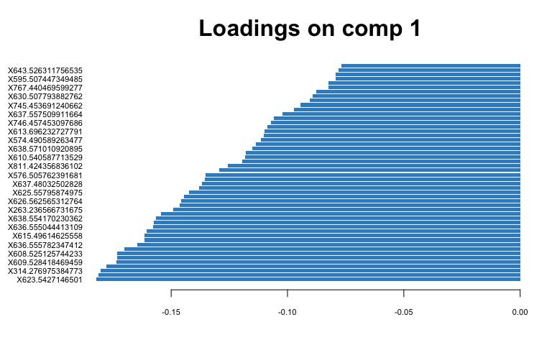

# plot loadings for comp 2  
plotLoadings(spca.res, comp = 2, ndisplay = 50)

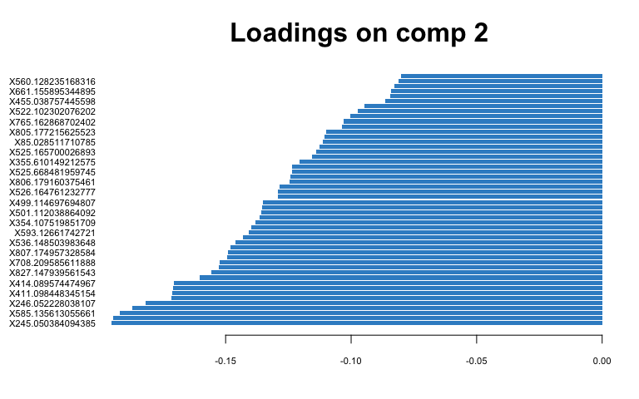

# Young Leaf  
spca.res <- mixOmics::spca(scaled_Y_young, ncomp = 3, keepX = c(100,   
 100, 10))  
  
# plot spca  
plotIndiv(spca.res, group = class$Fungus, ind.names = F, pch = as.factor(class$Water),   
 legend = T, legend.title = "Fungus", legend.title.pch = "Water",   
 title = "Young Leaf Secondary Metabolites (Pos) sPCA")

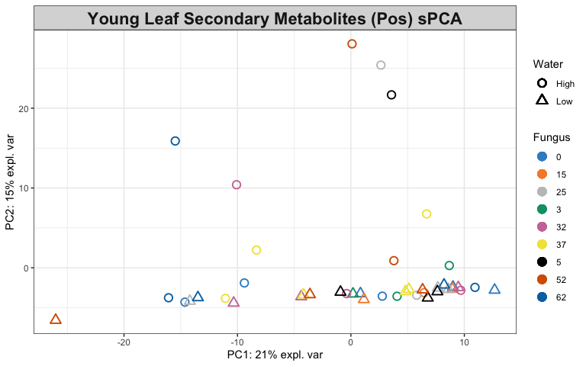

# variables contributing to each component  
plotVar(spca.res, cex = 1)

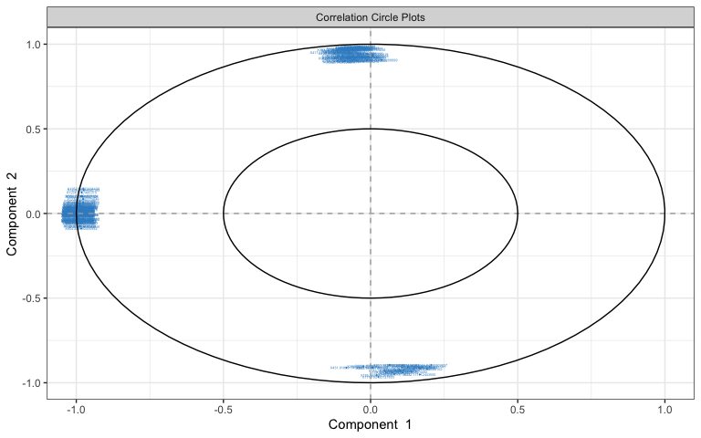

selectVar(spca.res, comp = 1)$value # view loading value of each metabolite

## value.var  
## X1241.5697122457 -0.139470661  
## X600.298086140669 -0.139175646  
## X1261.55339929009 -0.136132665  
## X600.799613678288 -0.134941320  
## X601.298910890415 -0.133563771  
## X1227.08434351864 -0.133521416  
## X618.78945764004 -0.131283246  
## X823.048160007084 -0.130587035  
## X1243.55304499525 -0.130195212  
## X1262.55961184041 -0.129412563  
## X1244.55236581133 -0.129116682  
## X617.286330873027 -0.126845950  
## X1226.08365485299 -0.125392084  
## X1334.67495005457 -0.125382708  
## X1226.58233140939 -0.124832612  
## X817.723367787991 -0.124618167  
## X1229.08860911037 -0.124494169  
## X618.289313527896 -0.124274416  
## X1225.58043983511 -0.123439455  
## X822.714478304939 -0.123348570  
## X817.383921636034 -0.123223780  
## X617.78775135641 -0.122810308  
## X351.839611703746 -0.122681247  
## X609.78630978679 -0.122479407  
## X1336.68057767421 -0.121862820  
## X1228.58307046331 -0.121824091  
## X823.382028411089 -0.121349640  
## X1335.67840490914 -0.120383444  
## X632.2869391849 -0.120231642  
## X609.284289758841 -0.119187887  
## X1236.57218581138 -0.119006491  
## X405.857226571577 -0.118923159  
## X613.285397218691 -0.118398301  
## X1281.57026969661 -0.117923790  
## X622.276956557877 -0.117908484  
## X1240.57686400951 -0.116112366  
## X1239.57370101026 -0.115179222  
## X550.256803920959 -0.114748723  
## X1227.57629691878 -0.114347942  
## X823.71615864327 -0.113434602  
## X1279.56562621519 -0.113192877  
## X608.782741019481 -0.112651258  
## X1263.56156390132 -0.112569764  
## X1234.06478512482 -0.112525354  
## X527.75634991554 -0.112363717  
## X519.772768355994 -0.111812009  
## X1337.6816954571 -0.111093133  
## X608.28119716139 -0.109601512  
## X1280.56909422237 -0.108275587  
## X813.047644882569 -0.108059038  
## X406.192592684012 -0.107786086  
## X631.785508659045 -0.106529676  
## X817.043002326106 -0.105118952  
## X1235.06677264887 -0.104034681  
## X611.287897439172 -0.103000870  
## X824.049066021535 -0.102789556  
## X631.284156543571 -0.102303243  
## X352.174656446785 -0.101512752  
## X1054.50423500233 -0.099237844  
## X601.799037963433 -0.098831516  
## X1242.56522633851 -0.096006929  
## X1228.07642334574 -0.094508987  
## X613.035765932759 -0.093906496  
## X818.056781338958 -0.091141400  
## X612.785606728103 -0.087550336  
## X651.781625860394 -0.085040210  
## X527.254671867446 -0.084059004  
## X1237.57084462266 -0.081084178  
## X1230.08774541731 -0.079219075  
## X519.270307691408 -0.078746834  
## X816.707450462089 -0.078302171  
## X651.28036531701 -0.076416993  
## X632.786594301567 -0.074710660  
## X813.376589649202 -0.073640219  
## X520.264679977611 -0.073469371  
## X550.759359335189 -0.069502467  
## X1229.5788769437 -0.068918200  
## X528.257744262133 -0.064983429  
## X1283.55588708327 -0.060901976  
## X654.285650435932 -0.060037126  
## X613.536347716772 -0.057915722  
## X1234.5707485375 -0.051899728  
## X838.372738715693 -0.049536575  
## X613.772591530124 -0.045920191  
## X535.247917849353 -0.044255968  
## X1037.52045054275 -0.040974710  
## X1305.53707639549 -0.039625742  
## X1053.50107517804 -0.037969267  
## X1264.55658857625 -0.037667817  
## X1222.57858095965 -0.036063657  
## X1237.0724873078 -0.034444605  
## X610.28370246133 -0.027216591  
## X1238.56292775646 -0.022181468  
## X1224.56843575939 -0.021649724  
## X812.714817179162 -0.020333869  
## X1231.52739997192 -0.020296654  
## X1252.54032434439 -0.015880601  
## X621.789191807783 -0.015879632  
## X1233.56564882193 -0.009690989  
## X779.416119584591 -0.001035685

# plot loadings for comp 1  
plotLoadings(spca.res, ndisplay = 50)

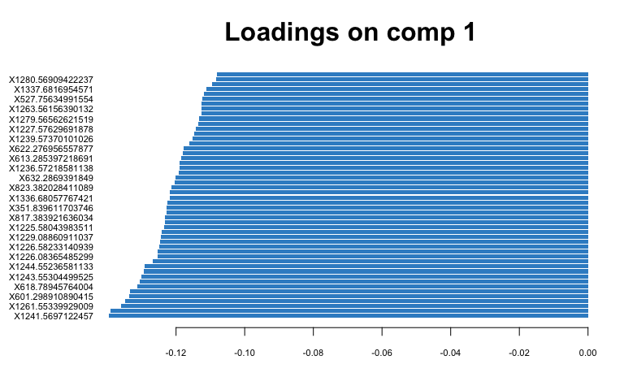

# plot loadings for comp 2  
plotLoadings(spca.res, comp = 2, ndisplay = 50)

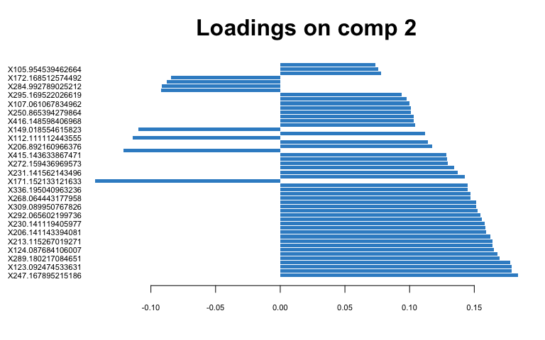

## PLS-DA

1. Classify samples into known groups and predict the class of new samples.

# Old Leaf  
old.splsda <- mixOmics::splsda(scaled_Y_old, class$Fungus, keepX = c(100,   
 100))  
  
# plot pls-da  
plotIndiv(old.splsda, ind.names = F, legend = T, title = "Old Leaf Secondary Metabolites (Pos) PLS-DA",   
 legend.title = "Fungus", ellipse = T)

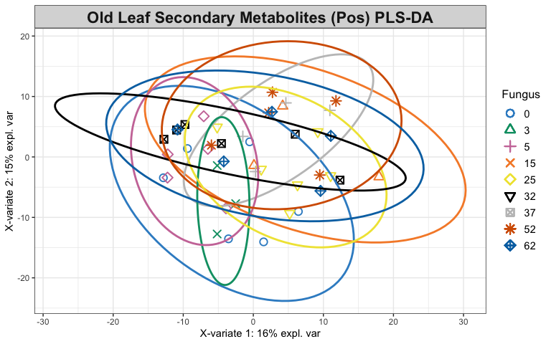

# plot and select the variables  
plotVar(old.splsda)

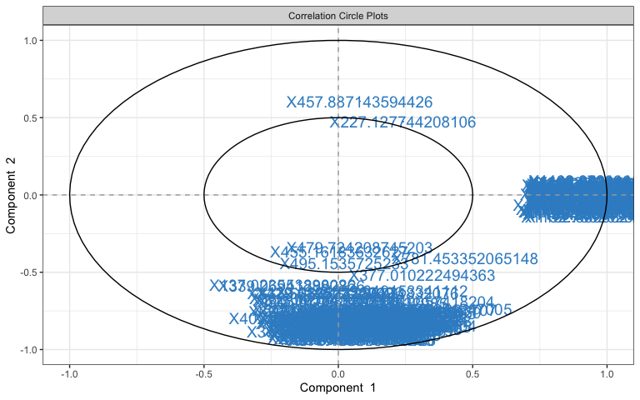

selectVar(old.splsda, comp = 1)

## $name  
## [1] "X1487.73406300404" "X1426.07694312396" "X1116.05305660839"  
## [4] "X1115.80460626783" "X1488.06760498806" "X1136.78228410413"  
## [7] "X1104.06862691242" "X1116.30428005847" "X1103.8218996643"   
## [10] "X1103.57319985526" "X1121.79675101528" "X1103.07299044082"  
## [13] "X1111.8096321385" "X1125.54778244133" "X1102.573154447"   
## [16] "X1116.80373735132" "X1132.03461103474" "X1122.29841750066"  
## [19] "X1127.79341899364" "X1129.54675650191" "X1136.53403742727"  
## [22] "X1131.28698128425" "X1108.81841229658" "X1110.06286552456"  
## [25] "X1114.56442916912" "X1107.8169646921" "X1138.28303782195"  
## [28] "X1102.82284449259" "X1426.40983069566" "X1122.04758243004"  
## [31] "X1117.30475357162" "X1115.05543333062" "X1425.73993768413"  
## [34] "X1132.53908246651" "X1109.81461712057" "X1133.54008365613"  
## [37] "X1121.29895737339" "X1112.5604640628" "X1121.54819054951"  
## [40] "X1125.79378838971" "X1126.29158820081" "X1108.06747930453"  
## [43] "X1102.32311155925" "X1122.5497312715" "X1126.5441441766"   
## [46] "X1470.09319447942" "X1123.30031266495" "X1112.81003971275"  
## [49] "X1103.32325021034" "X1129.29565171194" "X1112.30949170708"  
## [52] "X1108.31811054051" "X1488.40051943368" "X1471.42767786981"  
## [55] "X1117.04932871798" "X1469.75976780245" "X1470.42704875471"  
## [58] "X1127.04008421696" "X1131.78505133898" "X1470.76081907912"  
## [61] "X1113.56329850353" "X1098.56831395271" "X1469.42570146433"  
## [64] "X1135.53727745968" "X1112.05929178221" "X1113.31183863808"  
## [67] "X1108.56822391305" "X1131.03795724898" "X1471.09532086136"  
## [70] "X1127.29255917483" "X1114.06358094469" "X1129.79457145018"  
## [73] "X1109.06854325948" "X1125.30053856127" "X1485.74884256861"  
## [76] "X1135.28675162713" "X1489.399551935" "X1478.08739359233"  
## [79] "X1133.28887059062" "X1132.78820284397" "X1476.75330076931"  
## [82] "X1113.06007098305" "X1131.53755678079" "X1109.56623050873"  
## [85] "X1136.28695855805" "X1478.42215498284" "X1132.28893553294"  
## [88] "X1124.55354253246" "X1117.80491567323" "X1118.30495999252"  
## [91] "X1109.31799268981" "X1114.31354083018" "X1118.05504416426"  
## [94] "X1477.4205825873" "X1113.81293085655" "X1483.41064725665"  
## [97] "X1119.80974545454" "X1126.79208167921" "X1490.40376922173"  
## [100] "X1119.30886967612"  
##   
## $value  
## value.var  
## X1487.73406300404 0.2778109819  
## X1426.07694312396 0.2644217191  
## X1116.05305660839 0.2261700396  
## X1115.80460626783 0.2173284797  
## X1488.06760498806 0.1896116468  
## X1136.78228410413 0.1650091785  
## X1104.06862691242 0.1623645986  
## X1116.30428005847 0.1580176449  
## X1103.8218996643 0.1540609727  
## X1103.57319985526 0.1512505345  
## X1121.79675101528 0.1470020181  
## X1103.07299044082 0.1437882774  
## X1111.8096321385 0.1436423860  
## X1125.54778244133 0.1379262355  
## X1102.573154447 0.1333348419  
## X1116.80373735132 0.1311062999  
## X1132.03461103474 0.1268407388  
## X1122.29841750066 0.1249396606  
## X1127.79341899364 0.1247654543  
## X1129.54675650191 0.1244549039  
## X1136.53403742727 0.1223155601  
## X1131.28698128425 0.1212771304  
## X1108.81841229658 0.1212334363  
## X1110.06286552456 0.1201315088  
## X1114.56442916912 0.1181915572  
## X1107.8169646921 0.1167675478  
## X1138.28303782195 0.1165180686  
## X1102.82284449259 0.1156617829  
## X1426.40983069566 0.1149926752  
## X1122.04758243004 0.1146371796  
## X1117.30475357162 0.1121319305  
## X1115.05543333062 0.1087284570  
## X1425.73993768413 0.1086871253  
## X1132.53908246651 0.1080661707  
## X1109.81461712057 0.1059478384  
## X1133.54008365613 0.1031746286  
## X1121.29895737339 0.1015076025  
## X1112.5604640628 0.0945782327  
## X1121.54819054951 0.0914253886  
## X1125.79378838971 0.0909061512  
## X1126.29158820081 0.0889916026  
## X1108.06747930453 0.0879526826  
## X1102.32311155925 0.0878277012  
## X1122.5497312715 0.0870585837  
## X1126.5441441766 0.0860669559  
## X1470.09319447942 0.0851941163  
## X1123.30031266495 0.0849895564  
## X1112.81003971275 0.0828129627  
## X1103.32325021034 0.0804834482  
## X1129.29565171194 0.0792222380  
## X1112.30949170708 0.0755750879  
## X1108.31811054051 0.0741827212  
## X1488.40051943368 0.0738000496  
## X1471.42767786981 0.0705795509  
## X1117.04932871798 0.0680631925  
## X1469.75976780245 0.0677773708  
## X1470.42704875471 0.0670220233  
## X1127.04008421696 0.0617318264  
## X1131.78505133898 0.0614552161  
## X1470.76081907912 0.0607021936  
## X1113.56329850353 0.0575110057  
## X1098.56831395271 0.0552270918  
## X1469.42570146433 0.0547297316  
## X1135.53727745968 0.0525023044  
## X1112.05929178221 0.0499647663  
## X1113.31183863808 0.0499299039  
## X1108.56822391305 0.0484990599  
## X1131.03795724898 0.0467007621  
## X1471.09532086136 0.0465308757  
## X1127.29255917483 0.0465304054  
## X1114.06358094469 0.0430392118  
## X1129.79457145018 0.0426737863  
## X1109.06854325948 0.0425454117  
## X1125.30053856127 0.0384018869  
## X1485.74884256861 0.0361639550  
## X1135.28675162713 0.0355602328  
## X1489.399551935 0.0355471964  
## X1478.08739359233 0.0338542992  
## X1133.28887059062 0.0332983021  
## X1132.78820284397 0.0314452831  
## X1476.75330076931 0.0312544730  
## X1113.06007098305 0.0307244558  
## X1131.53755678079 0.0306259262  
## X1109.56623050873 0.0297866618  
## X1136.28695855805 0.0275403531  
## X1478.42215498284 0.0271748784  
## X1132.28893553294 0.0270411862  
## X1124.55354253246 0.0221139805  
## X1117.80491567323 0.0220497801  
## X1118.30495999252 0.0208404964  
## X1109.31799268981 0.0198891505  
## X1114.31354083018 0.0182593046  
## X1118.05504416426 0.0178664769  
## X1477.4205825873 0.0169645660  
## X1113.81293085655 0.0158796336  
## X1483.41064725665 0.0132492924  
## X1119.80974545454 0.0098193383  
## X1126.79208167921 0.0071816142  
## X1490.40376922173 0.0020508425  
## X1119.30886967612 0.0006404074  
##   
## $comp  
## [1] 1

plotLoadings(old.splsda, contrib = "max", method = "mean", ndisplay = 50)

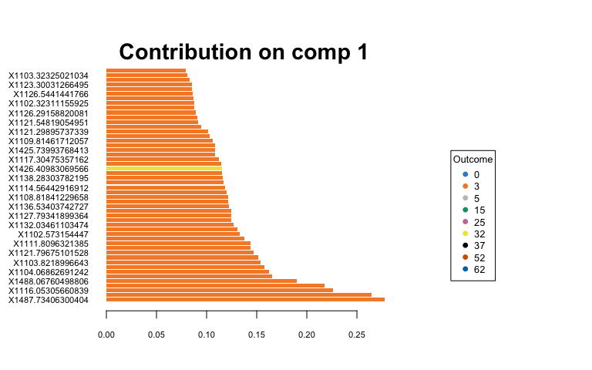

# Young Leaf  
young.splsda <- mixOmics::splsda(scaled_Y_young, class$Fungus,   
 keepX = c(100, 100))  
  
# plot pls-da  
plotIndiv(young.splsda, ind.names = F, legend = T, title = "Young Leaf Secondary Metabolites (Pos) PLS-DA",   
 legend.title = "Fungus", ellipse = T)

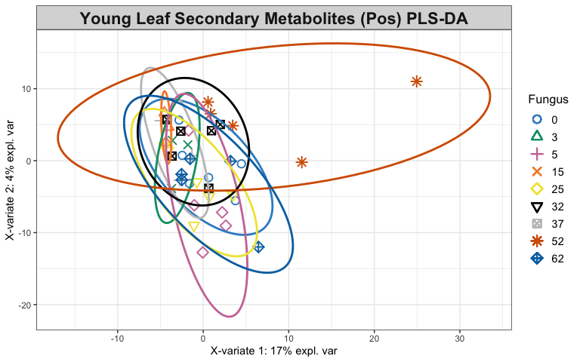

# plot and select the variables  
plotVar(young.splsda)

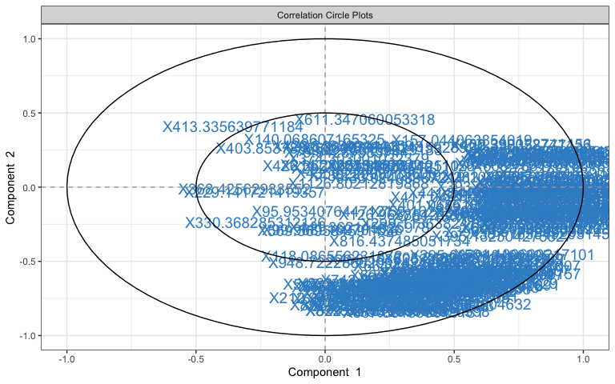

selectVar(young.splsda, comp = 1)

## $name  
## [1] "X435.265041264193" "X561.195153908566" "X191.142831050821"  
## [4] "X562.198826698276" "X220.933637304516" "X411.186748289517"  
## [7] "X433.024089572141" "X761.150139232025" "X417.049118108137"  
## [10] "X79.94287983744" "X201.887880425105" "X542.258263036671"  
## [13] "X562.199692173047" "X561.195521367934" "X592.2103604043"   
## [16] "X529.274978890623" "X622.22112991077" "X817.290953139684"  
## [19] "X273.167111911126" "X393.190249243473" "X229.141721419357"  
## [22] "X559.216971541369" "X576.211656573802" "X787.279327745226"  
## [25] "X137.061136253662" "X547.21588517482" "X147.042739890915"  
## [28] "X759.162827899809" "X419.041079838955" "X338.342115928924"  
## [31] "X608.783170750181" "X697.33374931113" "X559.181816091216"  
## [34] "X609.188818880262" "X598.248439099125" "X546.204470010442"  
## [37] "X361.091398476515" "X431.134225468165" "X214.253550469892"  
## [40] "X608.280771730718" "X545.200300816215" "X548.219043560918"  
## [43] "X559.308892423438" "X679.276723243348" "X327.160705477326"  
## [46] "X126.965854212842" "X627.205841547367" "X387.163549203145"  
## [49] "X591.206314720655" "X349.090515445971" "X678.27479236805"   
## [52] "X149.095689289718" "X219.102286597348" "X579.103775337199"  
## [55] "X295.087943490825" "X381.116290473037" "X396.136174296936"  
## [58] "X769.269913578792" "X368.42562933552" "X281.589541788573"  
## [61] "X771.283948428587" "X611.208506435124" "X607.209814001622"  
## [64] "X575.208493952074" "X459.153301042731" "X549.219252720572"  
## [67] "X282.095747416245" "X628.210632485529" "X547.216368593675"  
## [70] "X159.101695076237" "X655.189885840188" "X395.132504275827"  
## [73] "X330.368285312136" "X603.206683298622" "X402.358358777433"  
## [76] "X430.390022741156" "X595.222226186161" "X548.220348742993"  
## [79] "X157.044063854019" "X608.21522833073" "X179.070702928982"  
## [82] "X723.248094849444" "X375.14623697476" "X707.430538895667"  
## [85] "X540.245574294723" "X604.209992086111" "X593.221770649434"  
## [88] "X346.111503639577" "X374.303001032379" "X851.311747586913"  
## [91] "X498.217452455795" "X621.216851121727" "X500.210549877182"  
## [94] "X594.2254897838" "X435.022999713606" "X501.138397567176"  
## [97] "X1379.64356208646" "X441.244799903401" "X435.128173248124"  
## [100] "X401.068518225837"  
##   
## $value  
## value.var  
## X435.265041264193 0.258963679  
## X561.195153908566 0.246358522  
## X191.142831050821 0.238693289  
## X562.198826698276 0.237963492  
## X220.933637304516 0.237248512  
## X411.186748289517 0.222867792  
## X433.024089572141 0.218606675  
## X761.150139232025 0.212332555  
## X417.049118108137 0.209195273  
## X79.94287983744 0.195117208  
## X201.887880425105 0.171412375  
## X542.258263036671 0.163553226  
## X562.199692173047 0.154299165  
## X561.195521367934 0.152634222  
## X592.2103604043 0.147199177  
## X529.274978890623 0.141830874  
## X622.22112991077 0.137377777  
## X817.290953139684 0.134882524  
## X273.167111911126 0.129870163  
## X393.190249243473 0.120262756  
## X229.141721419357 -0.120047587  
## X559.216971541369 0.114792705  
## X576.211656573802 0.106310189  
## X787.279327745226 0.105770084  
## X137.061136253662 0.104912721  
## X547.21588517482 0.104665651  
## X147.042739890915 0.104086004  
## X759.162827899809 0.103561657  
## X419.041079838955 0.098130782  
## X338.342115928924 0.091404048  
## X608.783170750181 0.090990343  
## X697.33374931113 0.089838998  
## X559.181816091216 0.082511640  
## X609.188818880262 0.081541900  
## X598.248439099125 0.081463692  
## X546.204470010442 0.080079798  
## X361.091398476515 0.078486608  
## X431.134225468165 0.078440925  
## X214.253550469892 0.076089624  
## X608.280771730718 0.070627804  
## X545.200300816215 0.063329224  
## X548.219043560918 0.063225972  
## X559.308892423438 0.062664063  
## X679.276723243348 0.061463371  
## X327.160705477326 0.058134774  
## X126.965854212842 0.058067992  
## X627.205841547367 0.056609462  
## X387.163549203145 0.056225981  
## X591.206314720655 0.055010844  
## X349.090515445971 0.053976768  
## X678.27479236805 0.053139991  
## X149.095689289718 0.052029242  
## X219.102286597348 0.051889353  
## X579.103775337199 0.051834367  
## X295.087943490825 0.050970519  
## X381.116290473037 0.049560180  
## X396.136174296936 0.048273374  
## X769.269913578792 0.047746198  
## X368.42562933552 -0.046740608  
## X281.589541788573 0.045612957  
## X771.283948428587 0.042215253  
## X611.208506435124 0.041706940  
## X607.209814001622 0.040487259  
## X575.208493952074 0.040183163  
## X459.153301042731 0.039493252  
## X549.219252720572 0.038285218  
## X282.095747416245 0.036745489  
## X628.210632485529 0.036450168  
## X547.216368593675 0.036022686  
## X159.101695076237 0.033758763  
## X655.189885840188 0.033010829  
## X395.132504275827 0.032253564  
## X330.368285312136 -0.031975536  
## X603.206683298622 0.031005958  
## X402.358358777433 0.030979833  
## X430.390022741156 0.030323872  
## X595.222226186161 0.029635867  
## X548.220348742993 0.029628293  
## X157.044063854019 0.028907790  
## X608.21522833073 0.024580253  
## X179.070702928982 0.024301928  
## X723.248094849444 0.023929859  
## X375.14623697476 0.020281866  
## X707.430538895667 0.017609269  
## X540.245574294723 0.016430810  
## X604.209992086111 0.015782657  
## X593.221770649434 0.014237139  
## X346.111503639577 0.013165190  
## X374.303001032379 0.011635550  
## X851.311747586913 0.009264566  
## X498.217452455795 0.008973775  
## X621.216851121727 0.008646167  
## X500.210549877182 0.007840429  
## X594.2254897838 0.006764113  
## X435.022999713606 0.005054371  
## X501.138397567176 0.004307501  
## X1379.64356208646 0.001845171  
## X441.244799903401 0.001827014  
## X435.128173248124 0.001329296  
## X401.068518225837 0.001178817  
##   
## $comp  
## [1] 1

plotLoadings(young.splsda, contrib = "max", method = "mean",   
 ndisplay = 50)

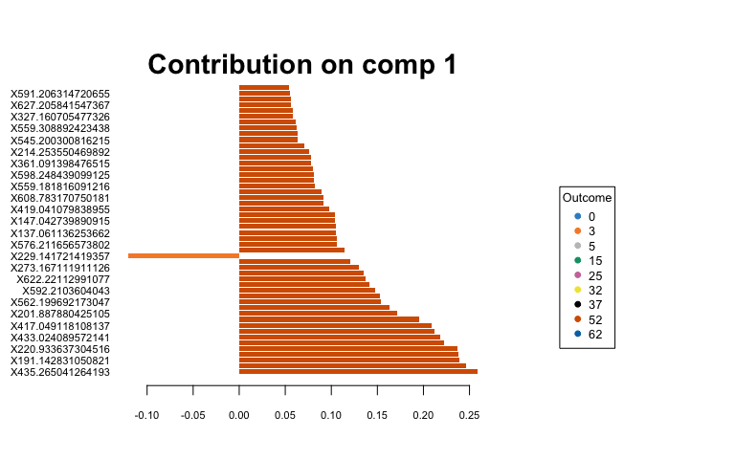

## Heatmaps of Averaged Data

1. Create averaged metabolite matrices and rerun PLS-DA to create a heatmap.

## Old Leaves  
av_Y_old <- aggregate(Y_old, by = list(class$Water, class$Fungus),   
 FUN = "mean", simplify = T, data = class)  
av.old.plsda <- mixOmics::plsda(av_Y_old[, 3:5802], av_Y_old$Group.2) # fungus  
  
# heatmap  
oldcim <- cim(av.old.plsda, title = "Old Leaf Secondary Met. (pos) Averaged Over Fungi",   
 col.names = F, xlab = "Secondary Metabolites", save = "png",   
 name.save = "~/Box/Summer 2018 TX Endo Field Samples and Analysis/Statistics/Kenia_Thesis_Analysis/Secondary Metabolites Statistics/old_water_avsmpos_hm.png") # by water treatment

## Indicator Analysis

1. Identify indicator metabolites characteristic of each treatment using Dufrene-Legendre Indicator Analysis.

# Old Leaf  
indicator_FungusO <- indval(Y_old, clustering = class$Fungus,   
 numitr = 999, type = "long")  
summary(indicator_FungusO)

##   
## Sum of probabilities = 3273.03903903904   
##   
## Sum of Indicator Values = 960.28   
##   
## Sum of Significant Indicator Values = 30.53   
##   
## Number of Significant Indicators = 147   
##   
## Significant Indicator Distribution  
##   
## 2 3 4 5 8 9   
## 98 3 38 4 1 3

# Young Leaf  
indicator_Fungus <- indval(Y_young, clustering = class$Fungus,   
 numitr = 999, type = "long")  
summary(indicator_Fungus)

## cluster indicator_value probability  
## X738.296098922098 1 0.2081 0.011011011  
## X1276.8016935537 2 0.1851 0.047047047  
## X1072.8337334809 2 0.1787 0.032032032  
## X167.97551825434 2 0.1761 0.040040040  
## X1140.82165943663 2 0.1714 0.044044044  
## X444.930683630603 2 0.1659 0.004004004  
## X275.163918393716 2 0.1633 0.027027027  
## X156.890008237947 2 0.1499 0.019019019  
## X1153.79792571483 2 0.1407 0.032032032  
## X229.141721419357 2 0.1387 0.001001001  
## X540.818241281503 2 0.1363 0.043043043  
## X313.01815211212 2 0.1352 0.011011011  
## X1246.76817339089 2 0.1219 0.029029029  
## X113.96385752929 3 0.1700 0.007007007  
## X1180.43827513436 3 0.1656 0.004004004  
## X703.214675604816 3 0.1595 0.033033033  
## X637.148466811858 3 0.1547 0.033033033  
## X702.214256834651 3 0.1543 0.026026026  
## X131.962746648011 4 0.2466 0.014014014  
## X169.287975931043 4 0.1941 0.009009009  
## X174.170106921473 4 0.1834 0.002002002  
## X86.0969059629987 4 0.1785 0.016016016  
## X320.864934443148 4 0.1750 0.040040040  
## X173.164828416272 4 0.1626 0.005005005  
## X115.964583574333 4 0.1568 0.049049049  
## X1280.77652898027 4 0.1546 0.023023023  
## X228.215068132004 4 0.1502 0.045045045  
## X1357.7663209951 4 0.1499 0.012012012  
## X500.822798296509 4 0.1458 0.037037037  
## X305.908971541333 4 0.1431 0.041041041  
## X1315.76786868364 4 0.1405 0.047047047  
## X1017.81968016253 4 0.1383 0.006006006  
## X907.835107134673 4 0.1338 0.047047047  
## X219.214947899134 4 0.1249 0.030030030  
## X887.351595919131 5 0.1924 0.046046046  
## X411.186748289517 8 0.2344 0.047047047  
## X433.024089572141 8 0.1953 0.028028028  
## X220.933637304516 8 0.1605 0.044044044  
## X435.265041264193 8 0.1532 0.035035035  
##   
## Sum of probabilities = 2145.67567567568   
##   
## Sum of Indicator Values = 564.14   
##   
## Sum of Significant Indicator Values = 6.39   
##   
## Number of Significant Indicators = 39   
##   
## Significant Indicator Distribution  
##   
## 1 2 3 4 5 8   
## 1 12 5 16 1 4

1. Disect indval object.

Orelfrq <- indicator_FungusO$relfrq # relative frequency of species in classes  
Orelabu <- indicator_FungusO$relabu # relative abundance of species in classes  
Oindval <- indicator_FungusO$indval # the indicator value for each species  
Omaxcls <- data.frame(indicator_FungusO$maxcls) # the class each species has max indicator value for  
Oindcls <- data.frame(indicator_FungusO$indcls) # the indicator value for each species to its max class  
Opval <- data.frame(indicator_FungusO$pval) # the probability of obtaining as high an indicator value as observed over the specified iterations  
  
Yrelfrq <- indicator_Fungus$relfrq # relative frequency of species in classes  
Yrelabu <- indicator_Fungus$relabu # relative abundance of species in classes  
Yindval <- indicator_Fungus$indval # the indicator value for each species  
Ymaxcls <- data.frame(indicator_Fungus$maxcls) # the class each species has max indicator value for  
Yindcls <- data.frame(indicator_Fungus$indcls) # the indicator value for each species to its max class  
Ypval <- data.frame(indicator_Fungus$pval) # the probability of obtaining as high an indicator value as observed over the specified iterations

1. Export results to a csv file.

write.csv(cbind(Orelfrq, Orelabu, Oindval, Omaxcls, Oindcls,   
 Opval), "~/Box/Summer 2018 TX Endo Field Samples and Analysis/Statistics/Kenia_Thesis_Analysis/Secondary Metabolites Statistics/Indicator_Analys_oSMpos_Fungus.csv")  
write.csv(cbind(Yrelfrq, Yrelabu, Yindval, Ymaxcls, Yindcls,   
 Ypval), "~/Box/Summer 2018 TX Endo Field Samples and Analysis/Statistics/Kenia_Thesis_Analysis/Secondary Metabolites Statistics/Indicator_Analys_ySMpos_Fungus.csv")

## References

Collyer, M.L., Adams, D.C. 2018. RRPP: An r package for fitting linear models to high-dimensional data using residual randomization. Methods in Ecology and Evolution. 9(7):1772-1779.

Dufrene, M. and Legendre, P. 1997. Species assemblages and indicator species: the need for a flexible asymmetrical approach. Ecol. Monogr. 67(3):345-366.

Rohart, F., Gautier, B., Singh, A., & Lê Cao, K. A. 2017. mixOmics: An R package for ‘omics feature selection and multiple data integration. PLoS computational biology, 13(11):e1005752.